

Evolt 360 Manual

Ticket and Service Desk Guide



Author: Lachlan Parris

Date: 4th August 2025

Version: 1.0

Contents

1 Overview 2

2 Support Material and Accounts 3

2.1 Supporting Documentation 4

2.2 Support Accounts 4

3 Evolt 360 Kiosk 5

3.1.1 Overview 5

3.1.2 Dimensions 5

3.1.3 Hardware Structure 5

3.1.4 Technical Specifications 8

3.1.5 Network Requirements 9

3.1.6 USB Ports And Support Devices 9

3.1.6.1 USB WIFI Adapter 9

3.1.6.2 Firmware upgrade USB 10

3.1.6.3 Printers 10

3.1.7 Operating Systems 11

3.1.8 Kiosk Software 11

4 Evolt Applications 11

4.1 Mobile Application 11

4.1.1 Overview 11

4.1.2 User Registration 12

4.1.3 User Interface 13

4.2 Insights Portal 13

5 Remote Access – TeamViewer 13

5.1 Accessing TeamViewer 14

5.2 Connect to a Remote Computer 14

6 Kiosk Setup 14

6.1 Kiosk Pre-Installation Requirements 15

6.1.1 Space and Environmental Conditions 15

6.1.2 Power Requirements 15

6.2 Unpacking and Inspection 15

6.3 Unit Assembly 15

7 Kiosk Installation 15

7.1 Hardware Components Checklist 16

7.2 Positioning the Device 16

7.3 Connecting Power Supply 17

7.4 Power Connection and Boot Sequence 17

7.5 Control Panel and Technician Interface 18

7.6 Connecting to Network (Ethernet) 25

7.7 Connecting to Network (WIFI) 25

7.8 Hardware Calibration 27

7.9 Kiosk Firmware Updates 27

7.10 Diagnostics and Screen Details 27

7.10.1 Diagnostic Mode and System Feedback 27

8 Performing A Scan 27

9 Kiosk Storage and Maintenance 27

10 Ticket Creation Process 27

10.1 Overview 27

10.2 Accessing the Ticketing System 27

10.2.1 Smart Questions to Ask the User to Help with Data Collection. 27

10.2.2 Saving and Assigning the Ticket 27

10.3 Sending Emails to users and Template creation. 27

5.4 Required Fields and Categorisation 27

10.4 Priority Levels and Assignment 27

10.5 Notes and Supporting Information 27

10.5.1 How to find ticket IDs in HubSpot 27

10.6 Escalation Procedures 27

10.6.1 Allocation Gaps & Risks 27

10.6.2 Knowledge and Ownership 27

10.7 Best Practices and Common Mistakes 27

11 Kiosk Troubleshooting Guide & Common Issues 27

11.1 Device Not Powering On 27

11.2 Faulty Handle 27

11.3 Faulty Scale Board 27

11.4 White Screen (“of Death”) 27

11.5 USB Device Recognition Errors 27

11.6 Network Connectivity (Wi-Fi vs LAN) 27

11.7 Wi-Fi Dongle Faults 27

11.8 User Profiles and Network Congestion 27

11.9 Troubleshooting Boot Failures 27

11.10 TeamViewer Issues and Resolution 27

12 Additional Notes and Recommendations 27

12.1 Summary of Observations 27

12.2 Lessons Learned During Setup 27

# Overview

This manual provides end-to-end guidance for the installation, configuration, use, and troubleshooting of the Evolt 360 System. It is intended for Service Desk technicians, support staff, and internal Evolt teams responsible for deployment and customer support.

Evolt 360 is a global body composition analysis platform delivered through a combination of hardware kiosks, software, and mobile app technology. The system is used in fitness centres to scan, record, and report on individual health metrics.

* AU Region – Isaac Deboer (Support Lead, Day Crew)
* US Region – Andrew Paugh (Support Lead, Night Crew)
* Head of Education – Elliot
* Senior Support Lead – Mitchell Todd (Repairs and Replacements)

All ticket activity is logged and tracked via HubSpot, segmented by ticket type, region, origin, priority, and queue assignment.  
  
The official Evolt Knowledge Base Library can be found here: <https://knowledge.evolt360.com/knowledge/evolt-360-scan-results>

# Support Material and Accounts

## Supporting Documentation

|  |  |
| --- | --- |
| Document | Link |
| Service Manual | [EV360_Service Manual.pdf](https://360evolt.sharepoint.com/:b:/r/sites/SupportandWearhouse/Shared%20Documents/Support%20team/Documents/Support/Doco/EV360_Service%20Manual_V1.1_ENG_20210324%20(1).pdf?csf=1&web=1&e=fv3FFF) |
| EV360 User Manual | [EV360 USER MANUAL.pdf](https://360evolt.sharepoint.com/:b:/r/sites/SupportandWearhouse/Shared%20Documents/Support%20team/Documents/Support/Doco/EV360%20USER%20MANUAL%20CE%20V3.0%2020220822%20EN.pdf?csf=1&web=1&e=TTIZyh) |
| Evolt 360 Safe Handling | [Evolt 360 Safe Handling](https://360evolt.sharepoint.com/sites/SupportandWearhouse/Shared%20Documents/Forms/AllItems.aspx?viewid=bfd5d292%2D2027%2D4594%2D9dfc%2De3f4776d804d&id=%2Fsites%2FSupportandWearhouse%2FShared%20Documents%2FSupport%20team%2FDocuments%2FSupport%2FDoco%2FEvolt%20360%20Safe%20Handling%20%5F%20Use%2Epdf&parent=%2Fsites%2FSupportandWearhouse%2FShared%20Documents%2FSupport%20team%2FDocuments%2FSupport%2FDoco) |

## Support Accounts

Evolt has provided Asta with two support accounts listed below:

1. Customer.support@evolt360.com
2. Customer.supportUSA@evolt360.com

The table below outlines the platforms accessed by these accounts along with the corresponding authentication methods required for each platform:

|  |  |
| --- | --- |
| Platform | MFA/Authentication Method |
| TeamViewer | Username and Password are used with a device requiring activation via the associated email. |
| Teams | One Time Pin via TextIt |
| Emails | One Time Pin via TextIt |
| HubSpot | MFA token emailed to email. |

Please refer to LastPass for the passwords associated with these accounts.

# Evolt 360 Kiosk

## Overview

The **EV360 kiosk** is a sophisticated body composition analysis device designed for health, fitness, and wellness environments. It uses **bioelectrical impedance analysis (BIA)** to measure body composition metrics such as:

* **Muscle mass (SMM)**
* **Body fat percentage (PBF)**
* **Basal metabolic rate (BMR)**
* **Total body water (TBW)**
* **Segmental analysis** (arms, legs, trunk)
* **Abdominal fat analysis**
* **Protein and mineral mass**
* **Body composition changes tracking**

It operates using a **tetra-polar electrode method** with 8 touch electrodes and measures at multiple frequencies (5, 50, and 250 kHz). The kiosk is equipped with a **12.5-inch colour LCD touchscreen**, USB and HDMI ports, and Ethernet connectivity

## Dimensions

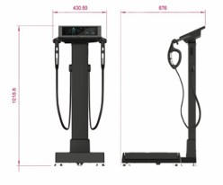

## Hardware Structure

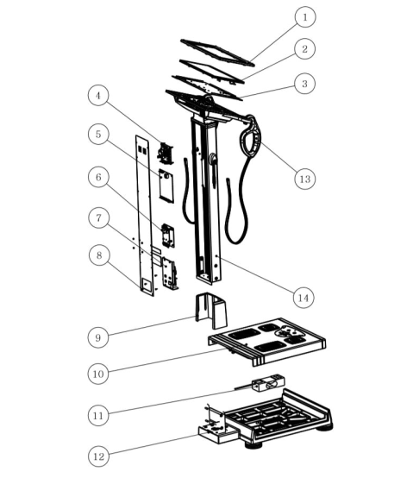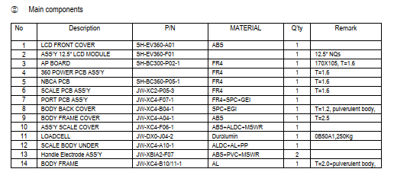

Front Panel

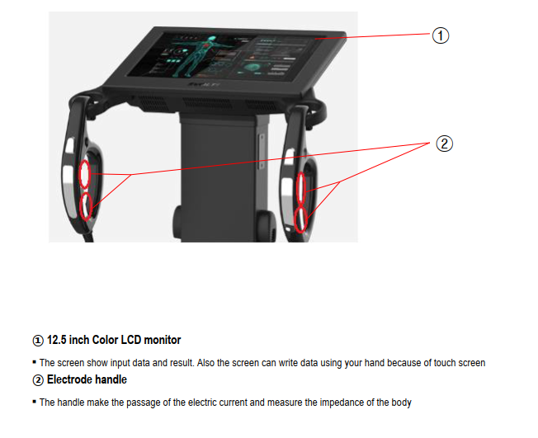

Back Panel

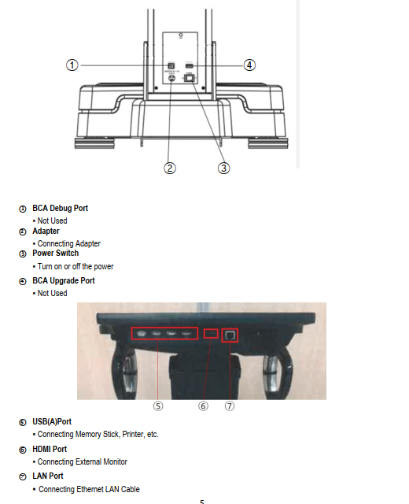

Base Plate

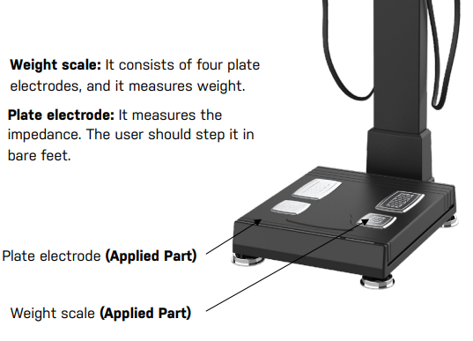

## Technical Specifications

|  |  |
| --- | --- |
| Specification | Details |
| Model | EV360 |
| Measuring Method | Tetra-polar electrode method using 8 touch electrodes |
| Frequency Range | 5, 50, 250 kHz |
| Measuring Site | Whole body and Segmental (arms, legs, trunk) |
| Current | Within 180µA ± 15 |
| Power Supply | Input: 100-240VAC, 50/60Hz, 1.5 A Output: +12V, 5.0A |
| Display | 12.5-Inch-Wide Colour LCD |
| Input Device | Touch screen |
| Network Connectivity | 1 x Ethernet Port  (WIFI compatible via WIFI USB dongle) |
| Transmitting Device | 3 x USB port  1 x HDMI Port  1 x Ethernet Port |
| Printing Device Connectivity | USB or Ethernet |
| Dimension | 430×676×1020mm (D × W × H, +10mm) |
| Weight | About 19kg / Approx. 41.8lbs |
| Measuring Range | 100 ~ 950 Ω |
| Measuring Time | Approx. 30 seconds |
| Input Height | 50 ~ 220 cm / 1ft 7.7in ~ 7ft 2.6in |
| Measuring Weight | 10 ~ 250 kg / 22lb ~ 551.1lbs |
| Applicable Age | 7–99 (Subject to valid age of consent in applicable jurisdiction) |
| Operation Ambient | Temp: +5 to +40 °C Humidity: 15 to 93% (non-condensing) Pressure: 70–106 kPa |
| Storage Ambient | Temp: -25 to +70 °C Humidity: <93% RH |
| Software Name & Version | EV360 .AP.1.0.19 BCA-CE3F/V5.26.G VNBCA-360/v0.19.2 |

## Network Requirements

* **Preferred Connection:** Ethernet is recommended for stable and reliable connectivity.
* **Wi-Fi**: Acceptable for use; however, it may be less reliable in certain regions, especially internationally.
* **Personal Hotspot:** Can be used as an alternative connection method.
* **USB Stick:** Required for enabling Wi-Fi functionality. Ensure the USB stick remains always connected to the scanner.

## USB Ports and Support Devices

## USB WIFI Adapter

The kiosk will be delivered with a Wi-Fi USB adapter, which facilitates wireless connectivity. This adapter allows the kiosk to connect to both 2.4 GHz and 5 GHz wireless networks, ensuring flexibility and optimal performance depending on the network environment. With this feature, users can easily access the internet and other online services, enhancing the overall functionality of the kiosk.

The device should not be removed while powered on, as this can cause connectivity failures or upload issues. Removing the firmware USB may impact device stability. While it's possible to remove USBs with the unit off, it’s not recommended without guidance from Evolt support.

## Firmware upgrade USB

The kiosk will come equipped with a 32GB USB drive specifically designated for firmware purposes. This USB drive plays a crucial role in the company's internal processes, as it is used for performing manual firmware updates and configuring the device settings as needed. Although the presence of the USB drive will not disrupt the kiosk's everyday functioning, it becomes essential when addressing any technical issues that may arise. Additionally, it is necessary to reinstall the software to ensure optimal device performance. Therefore, having this USB drive on hand is important for maintaining the kiosk's reliability and addressing any potential challenges efficiently.

## Printers

The remaining USB ports on the device are designated for connecting compatible printer hardware. Specifically, only certain Brother printer models are supported and included with the Evolt 360. It is important to note that printers from other brands, such as Epson, are not compatible with this system. Ensure that you use one of the designated Brother models to achieve optimal performance and functionality. Please refer to the list below of supported models.

|  |
| --- |
| Compatible Printer models |
|  |

## Operating Systems

The EV360 kiosk uses the Linux operating system for its stability, security, and cost-effectiveness, making it perfect for public-facing applications. Linux’s built-in security and reliability minimise downtime while its open-source nature allows for customisation, streamlining the user experience. Additionally, it avoids licensing fees associated with proprietary systems like Windows, reducing the total cost of ownership. Please be aware that Asta does not support the operating system, and any issues attributed to the operating system should be escalated to Evolt immediately.

## Kiosk Software

# Evolt Applications

## Mobile Application

#### Overview

The Evolt Active App serves as an intuitive mobile companion, designed to seamlessly interact with the Evolt kiosk and enhance your health and fitness experience. With this app, users can:

* Tracks personalised health goals like fat loss or muscle gain
* Provides over 40 body composition metrics
* Offers AI-based macronutrient recommendations
* Stores scan data securely in the cloud
* Includes educational content on nutrition and wellness
* Suggests supplements based on individual scan results
* Enables community sharing and engagement
* Syncs with other health and fitness apps
* Automatically uploads scan results or allows manual entry
* Displays progress with interactive graphs
* Helps locate nearby Evolt 360 scan stations
* Allows profile customization and unit preferences

|  |  |  |  |
| --- | --- | --- | --- |
| Platform | Minimum OS Version | Hardware Requirements | Connectivity |
| Android | Android 6.0 or higher | At least 2 GB RAM,  100 MB space | An internet required for syncing |
| iOS | iOS 12.0 or later | Compatible with iPhone, iPad, iPod touch; 100 MB space | Wi-Fi or mobile data required |

Download Links

* **Apple App Store**: [Download for iOS](https://apps.apple.com/us/app/evolt-active/id1464632516)
* **Google Play Store**: [Download for Android](https://play.google.com/store/apps/details?id=com.evoltactive.app2019&hl=en-US)

#### User Registration

When a user logs into the mobile app for the first time, they will be presented with the welcome screen, which introduces them to the initial setup process.

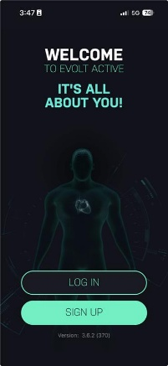

Following pressing SIGN UP, the users will be presented with subsequent screens to provide all the details required to set up the account and their profile.







On the final screen, the user will be sent an email requiring them to validate that they are the person registering the account. Once this is completed, the user can press, I’VE ACTIVATED.

Once completed, the user will be sent back to the initial sign-in screen to log into the account

#### User Login

When users already have an activated account, they can simply select LOG IN.

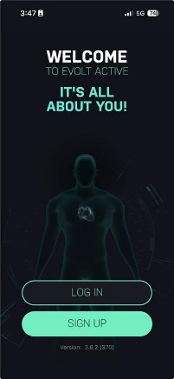

This will send users to the account login screen, where they can enter their email addresses and passwords.

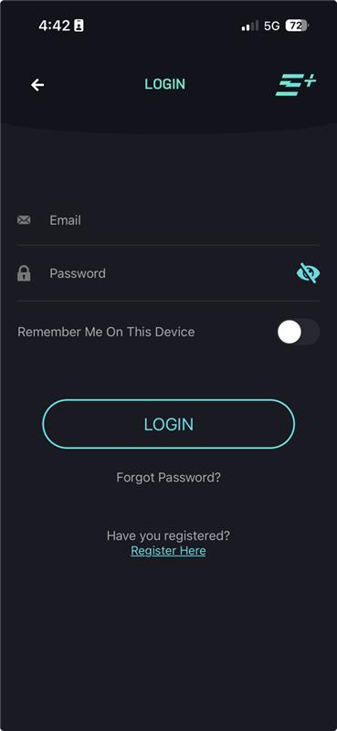

If a user has forgotten their password, they can initiate a password reset request. Upon doing so, a reset email will be sent to their registered email address, allowing the user to verify their identity and securely create a new password to regain access to their account.

### 4.1.2 User Interface

**1. How can a user view their scans?**  
*If scans are missing from a user account or they want to view their scans, users can easily view their historical scans within the Evolt Active App.*   
  
Please see this KB article for more assistance: <https://knowledge.evolt360.com/knowledge/how-can-i-view-my-scans>**2. How can a user print, share or download a hard copy of their scan results?**  
Please see this KB article for assistance:[**https://knowledge.evolt360.com/knowledge/how-can-i-print-my-results**](https://knowledge.evolt360.com/knowledge/how-can-i-print-my-results)**3. How can users add their scans manually to your Evolt Active App**  
In case a scan wasn’t automatically recorded  
  
Please see this KB article for assistance: <https://knowledge.evolt360.com/knowledge/how-to-add-your-scans-manually-to-your-evolt-active-app>

**4.1.3 Evolt App Troubleshooting**  
  
**1. Evolt Account is not found when logging in for a scan.**   
If their account cannot be located, check;

* **Ensure they’re using the correct registered email**
* **Prompt user to reset password on Log in screen.**
* **Confirm their account has been activated via email.**

View this KB article: <https://knowledge.evolt360.com/knowledge/evolt-account-is-not-found-when-logging-in-for-a-scan>

## 2. How can a user delete a scan? To delete a scan, log in to your Evolt Active App using your mobile phone or visit our website at <https://app.evoltactive.com/>using a computer. Click on the 'View my scans' scroll down, and choose the 'Remove scan' button. See this KB article for more details: <https://knowledge.evolt360.com/knowledge/how-do-i-delete-a-scan>

# Insights Portal

This is not currently supported due to a lack of access. This can be populated as required later.

# Kiosk Setup

## Kiosk Pre-Installation Requirements

### Space and Environmental Conditions

To ensure optimal operations, place the kiosk in a clean, dry, and level area with adequate space around the unit. A clearance of at least 1 metre on the left/right sides is recommended for safe access and user comfort.

Avoid areas with direct sunlight, high humidity, or exposure to dust and extreme temperatures. The kiosk should be positioned on a hard, stable surface to ensure accurate measurements.

Ensure easy access to a nearby power outlet and stable network connectivity, if applicable.

### Power Requirements

* Power must be supplied via a **direct wall outlet,**
* **Do not use** a power board or surge protector
* AU and US cords are provided; use the correct cord for your region

### Unpacking and Inspection

* Open packaging carefully, the machine is padded well, so it always remains secure during transit and doesn’t get any damage.
  + For a full unboxing and setup walkthrough, please visit this link: <https://knowledge.evolt360.com/knowledge/setting-up-your-evolt-360-scanner>

### Unit Assembly

The kiosk is shipped disassembled into two sections:

* 1. the scale base
  2. the upper body assembly.

Secure the vertical frame to the weighted base using the provided screws. Fasten both screws with the included Allen key to ensure stability.

# Kiosk Installation

## Hardware Components Checklist

* 1 x Body Scanner Analyser
* 1 x Allen key (provided in packaging)
* 2 x screws that stabilise the kiosk screen
* 1 x Network LAN cable (if applicable)
* Compatible printer (Usually included when the Gym manager orders the machine)
* Power supply unit (with AU and US power cord for versatility)
* 1 x neck cover that slides over the bottom of the machine where the screws were installed.

## Positioning the Device

* Place the kiosk in a clear, stable area with direct access to a wall power outlet
* Position the kiosk screen upward facing and use the 2 x screws to secure the kiosk screen upright.
* Attach the neck cover; this should simply slide onto the base of the kiosk where we joined the screws.

## Connecting Power Supply

1. Plug the AU power cord into the base of the device and into the corresponding wall outlet
2. Turn on the device by turning on from the wall outlet first and then hit the Power switch to ON.

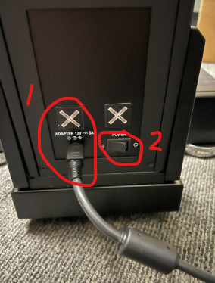  
  
*This should be the boot-up process for the Evolt360 kiosk.*

## Power Connection and Boot Sequence

1. **Power Cable:**
   1. The kiosk is supplied ONLY with both AU and US standard power cables. Ensure the AU cable is used for deployment in Australia.  
      Other countries that uses other plugs will be required to obtain their own inbound adaptors to adapt the included AU plug to the destination country sockets.
2. **Power Connection:**
   1. Connect the power cable to the rear base of the kiosk. **For reliable operation, plug the unit directly into a wall power socket**. Power boards or extension cables may not be sufficient and are not recommended.
3. **Powering On:** 
   1. Turn on the power switch located near the base of the unit to begin the boot process.

## Control Panel and Technician Interface

The Control Panel is primarily accessed by internal support or the service desk to provide an overview of the system’s health, settings, and diagnostics. It enables staff to configure, troubleshoot, and manage the kiosk efficiently.

**General Layout**

At the bottom of the screen, an **Online/Offline status indicator** is displayed.

* **Green** indicates that the system is successfully connected to the internet.
* **Red indicates that there is no internet connectivity.**

This status is vital for determining if scans can be uploaded and if network-dependent features will function as expected.

**Key Diagnostics Settings**

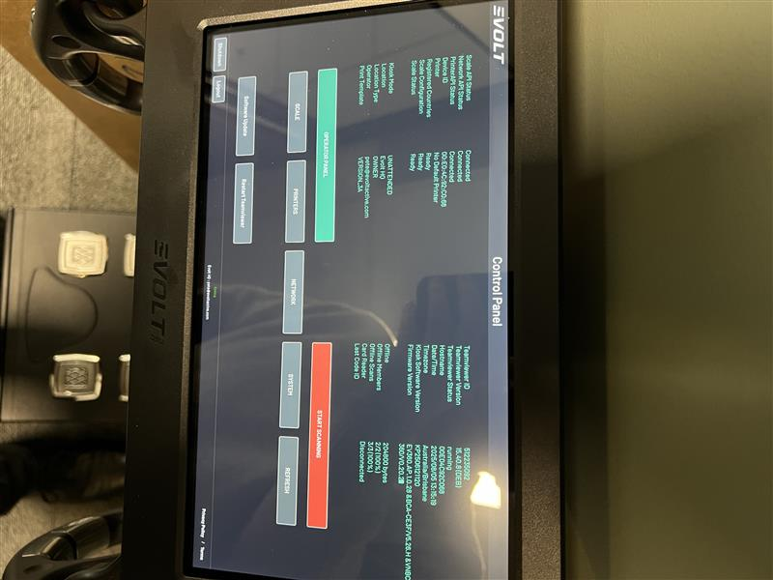**Already visible Diagnostics and what they mean:**

|  |  |
| --- | --- |
| Scale API Status | Connected/Disconnected |
| Network API Status | Connected/Disconnected |
| Printer API Status | Connected/Disconnected |
| Device ID | [MAC Address] |
| Printer | [Printer Name] |
| Registered Countries | Ready |
| Scale Configuration | Ready |
| Scale Status | Ready |
| Kiosk Mode | Attended/Unattended |
| Location | EvoltHQ |
| Location Type | OWNER |
| Operator | [Technician email details] |
| Print Templates | VERSION_3A |
| TeamViewer ID | [ID] |
| TeamViewer Version | [TeamViewer Version] |
| TeamViewer Status | [TeamViewer Status] |
| Hostname | [Hostname assigned] |
| Date/Time | [date and time] |
| Time zone | Australia/Brisbane |
| Kiosk Software Version | [Software Version] |
| Firmware Version | [Firmware Version] |
| Offline | [Offline Date in bytes] |
| Offline Members | [Offline Members Count] |
| Offline Scans | [Offline Scan Count] |
| Card Reader | Connected/Disconnected |
| Last Code ID | Does not have a value |

1. Operator Panel

This tab is one of the most used in support situations.

* If the kiosk **does not display the ‘Start Scanning’ button**, it likely means the device has been logged out. To resolve this:
  + Select the green “**Operator Panel”** button.
  + Log back into the system using the appropriate credentials.
  + Tell the user to hit refresh button after logging back in.
* If the user does not know their credentials, please visit this link: <https://knowledge.evolt360.com/knowledge/what-is-my-operator-panel-log-ins>
* You can find the login credentials under the machine   
  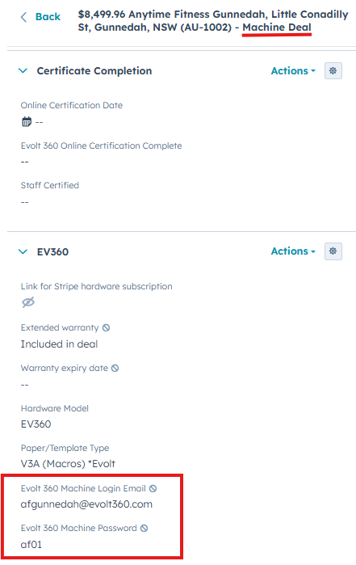

Once logged in, you will be directed to the Operator Configuration Menu, which includes:

* **Location Selector (Dropdown):** In most instances, only one location is listed for selection.
* Attended/Unattended Mode:
  + Recommended Setting: **Unattended**

*Ensures a smoother user experience. Especially preferred by gyms like Anytime Fitness and Areevo, where body scans are part of the membership.*

* **Printing Mode (Off / Manual / Auto):**
  + **Manual prompts the user before printing.**
* **Volume Control:** Range of 0-100.
* **Cancel / Save:** Save must be selected to commit changes.

After saving, return to the Control Panel. To re-enable scanning, reopen the Operator Panel, confirm settings, and press **Refresh;** the “Start Scanning” button should not be visible.

1. **Start Scanning**

This button returns the device to the end-user interface and enables customer scans.

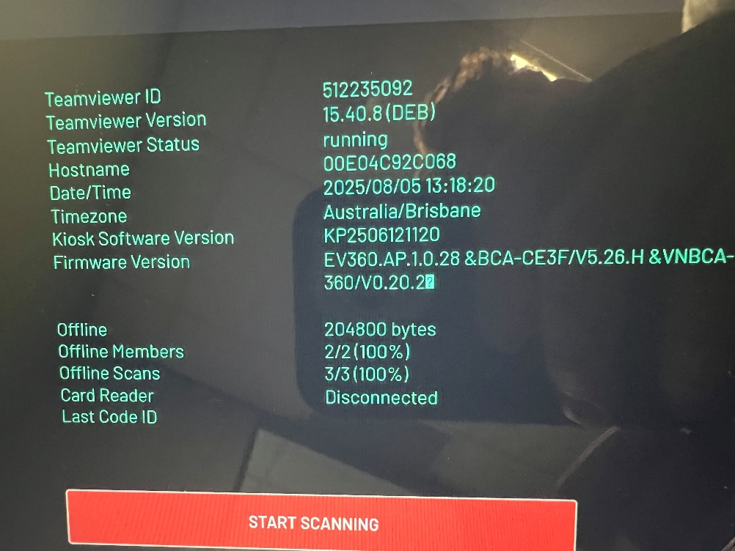

If the Start Scanning button isn’t reappearing, please visit this link: [https://knowledge.evolt360.com/knowledge/no-start-scanning-button.](https://knowledge.evolt360.com/knowledge/no-start-scanning-button)  
  
Furthermore, if the issue persists, ask the user to submit this Evolt Scanner Support Ticket: https://offers.evolt360.com/scanner-printe.r-support**ale Configuration.**

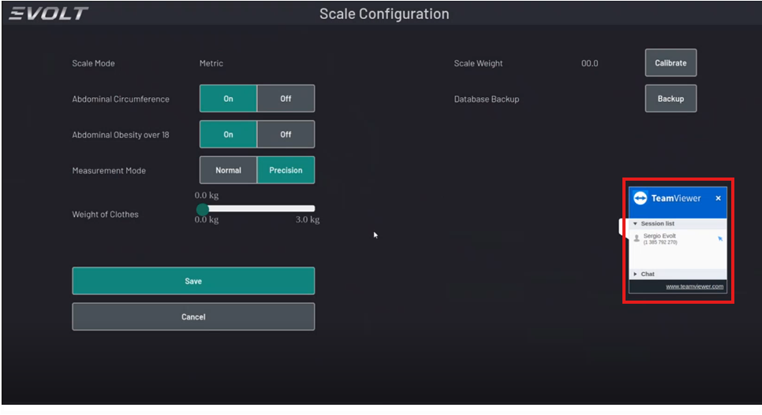

Used by gym staff or trainers to calibrate or recalibrate the scale. After making changes, remember to press **Save.**

* **Weight/Scale Calibration:** For a full walkthrough on this, please see this link: <https://knowledge.evolt360.com/knowledge/calibrating-scanner>

1. **Printers**

This tab is used to configure compatible printers.

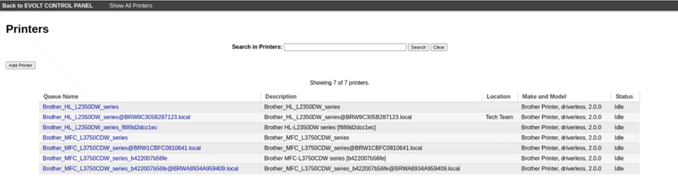

* **The system currently supports specific Brother models only (e.g., Brother MFC or Brother HL series).** 
  + To view compatible Printers, please see this link: <https://knowledge.evolt360.com/knowledge/compatible-printer-s>
  + For connecting a supported printer to the Evolt 360 Body Scanner, please visit this link: <https://knowledge.evolt360.com/knowledge/connect-the-printer-to-the-evolt-360-body-scanner>
* If troubleshooting steps do not resolve the issue, please ask the user to lodge a Printer Support ticket listed here: <https://offers.evolt360.com/scanner-printer-support>

1. **Network Configuration**

**This is where Wi-Fi and LAN settings are adjusted.**

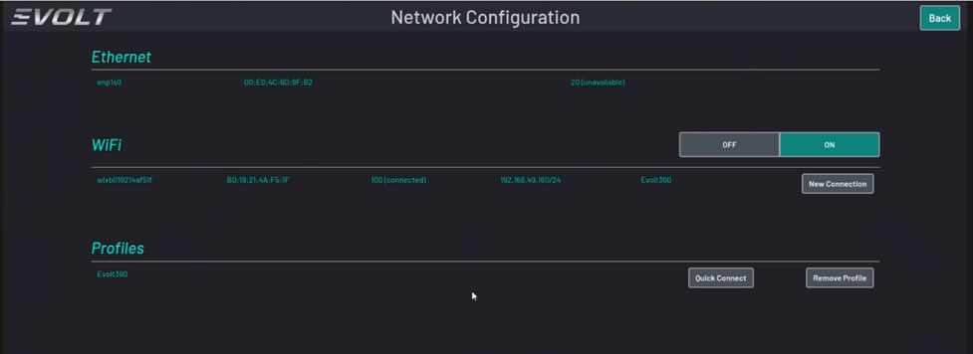

* **Important:** the kiosk relies on a **USB** **Wi-Fi dongle.** If this is removed:
  + The system will not allow new connectors.
  + Available network profiles may not appear.
* Setup Steps:
  + 1. Toggle Wi-Fi to On.
    2. Wait for the “New Connection” button to appear and select it.
    3. A list of available networks will populate after a few seconds.
    4. Select the desired network and enter the password.
    5. Confirm that offline status switches to Online (button indicator).
    6. Press Back to return to the Control Panel.
  + If there is no option to add “NEW CONNECTION”, visit this link:  
    [**https://knowledge.evolt360.com/knowledge/no-option-to-add-new-connection**](https://knowledge.evolt360.com/knowledge/no-option-to-add-new-connection)

**Note:** In regions like Southeast Asia, poor Wi-Fi reliability has been observed. In such cases, a LAN cable connection is strongly recommended.

1. **System**

This section provides detailed system settings:

* **Lock USB: On / Off**
  + Off – USBs are recognised and functional (default and recommended)
  + 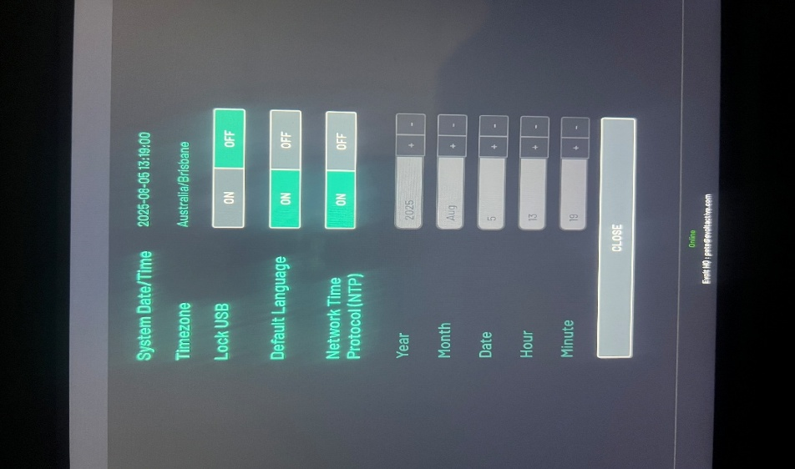On – USB ports are disabled, affecting Wi-Fi functionality and firmware recognition.
  + Any changes made must be saved manually.
* **Time zone Settings:** 
  + Sometimes users report a mismatch (e.g., Brisbane users seeing Melbourne time).
  + If time zone correction is needed:
    - Take a photo of the System tab.
    - Escalate to the Evolt Insights Team via the service desk.
* **Other configuration Info:** Includes system name, ID, and software version (used for diagnostics).

7. **Refresh**

This button should be clicked after:

* Saving Control Panel changes
* Completing **software updates**
  + For more information, please visit this link: <https://knowledge.evolt360.com/knowledge/software-update>
* Logging in/out of the Operator Panel

It helps apply and reflect recent changes promptly.

8. **Bottom Left Menu Options**

* **Software Update:**

Used for initiating software updates.

* **Restart TeamViewer:**

Uninstalled and reinstalled TeamViewer automatically for remote support

* **Shutdown:**

Power down the device.

* **Log Out:**

Occasionally required when user tokens become invalid. It is recommended that users refresh their tokens monthly to prevent login issues.

## Connecting to Network (Ethernet)

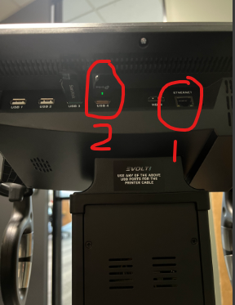

**Option 1 (Ethernet Connection)**

* Plug the Ethernet cable into the **LAN port** for a more reliable connection

**Option 2 (Wi-Fi Dongle)**

* Wi-Fi is possible via internal USB adapter but may vary in reliability  
  **Do not remove** either USB stick unless the machine is completely powered off.

For a detailed walkthrough of connecting the Evolt 360 Body Scanner to the internet, please visit this link: <https://knowledge.evolt360.com/knowledge/how-to-connect-to-the-network>

## Connecting to Network (WIFI)

Step-by-step guide to connecting the kiosk to the network. Wi-Fi configuration, Ethernet setup, testing, and troubleshooting documentation are also covered further in the document.   
  
**Step 1**. Access the Control Panel by pressing the Evolt logo in the top left corner of the Log In/Sign up Screen.

**Step 2.** Tap on ‘Network’  
  
**Step 3.** If you are connecting the scanner to Ethernet, the Ethernet section should show ‘100 connected if the Ethernet cord is plugged in to the port behind the screen and the port in your facility is actively running internet.

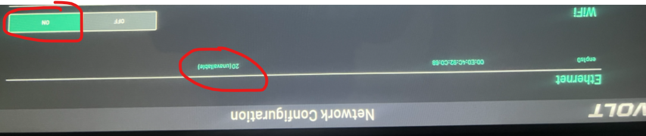

**Please Note:** *Here you can see that if Ethernet is disconnected, it reads ‘20(unavailable)’  
If you are connecting via Wi-Fi, make sure that it is turned ON.*

**Step 4.** Tap on ‘New Connection’, then connect to the preferred network.   
  
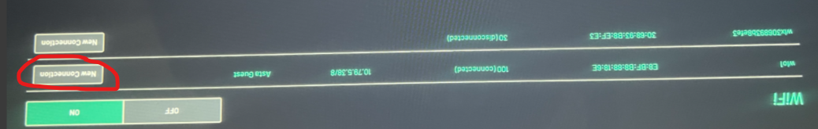

**Step 5.** Make sure that we are entering the correct password for your selected network.   
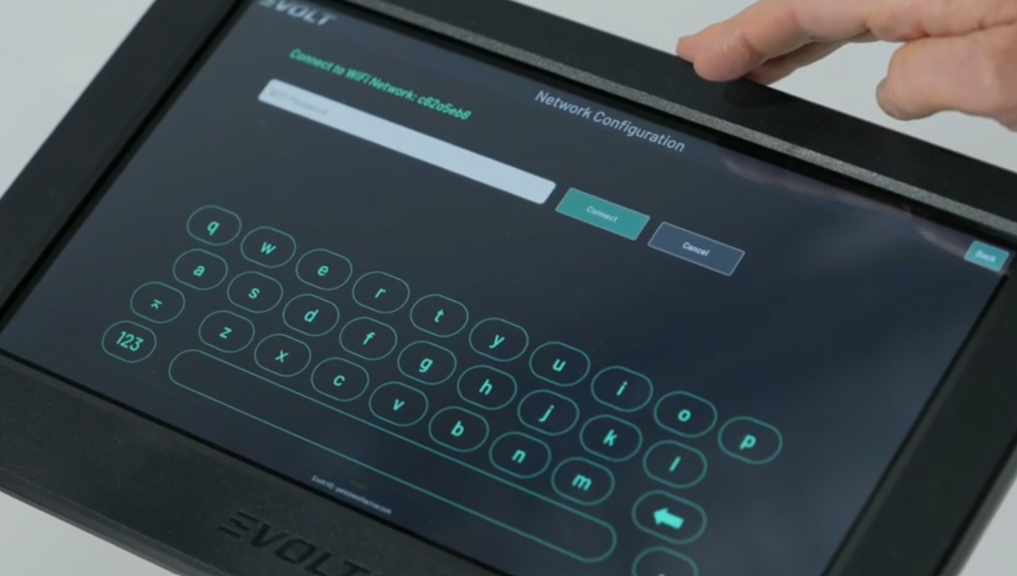  
*If the user is uncertain about their password, attempt connecting to the Wi-Fi on another device, such as a mobile phone or computer, and manually input the password to verify its accuracy.***Step 6.** To confirm the Wi-Fi connection, ensure that it displays ' ‘100 connected’ and ‘Online’ in green at the bottom-centre of the screen.   
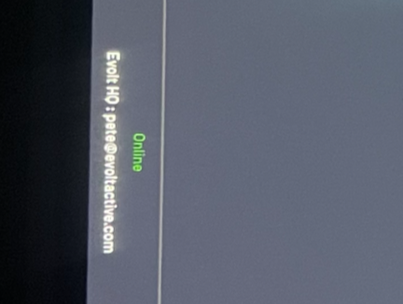  
  
**Please note:** *the Evolt Scanner can still be used for scanning if it is offline and not connected to the internet. However, it will not synchronize the scan results with the Evolt Active App or Insights Dashboard until it is reconnected to the internet.*

## Hardware Calibration

Once the Evolt 360 kiosk is powered on, the system will initiate its startup sequence. The boot sequence screens will appear in the following order:

* **Terminal Boot Screen**: Displays system-level startup messages as the device begins its initialisation.
* **Linux OS Desktop Interference:** This screen may briefly appear during boot. It is not intended for end-user interaction and should not be used or altered. Users are advised to **avoid interacting with this interface**, as it is reserved for backend processes and administrative support use only.
* **Evolt Control Panel:** Once the system has successfully booted, the Evolt operating interface (Control Panel) will load. This is the approved environment for performing scans, configuring settings, and accessing user data.

Finally, the system transitions to the user-facing interface. This is the default view used by clients/members to perform scans.

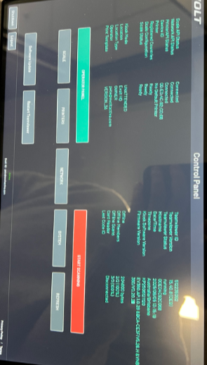

## Kiosk Firmware Updates

Firmware updates can be rolled out on a case-by-case basis. If the device operates reliably and meets all performance expectations on the current firmware, there is no urgent need to update. Stability and functionality take priority. Our objective as Service Desk technicians is achieved if the system performs as expected without requiring an update. The user will need a wired keyboard.

**Reasons for Firmware Update**

* Reimaging the device to factory settings.
* Addressing critical issues or bugs not resolved by regular software updates.
* Performed selectively based on operational need, not part of routine maintenance.

**Firmware USB Contents**

The USB device used for firmware updates contains the necessary installation files and scripts to reimage the device.   
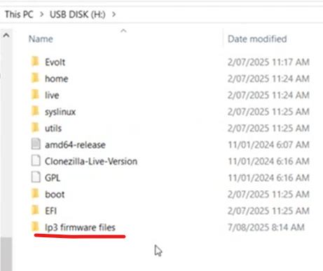  
  
**Firmware Update Procedure**

**1.** Ensure the kiosk is powered off.

2. Instruct the user to connect the USB to their computer.

3. Guide them through extracting the LP3 Firmware files and placing them in the root directory of the USB drive (USB DISK (*:),

4. Safely eject the USB and reinsert it into the kiosk.

5. Power off the kiosk for at least 5 seconds, then power it back on.

6. Prompt the user to repeatedly tap the Esc key during boot to access the BIOS menu.

7. Navigate to the Save and Exit menu, where the USB device will appear as a boot option.

8. Select the USB drive to boot from and begin the reimaging process.

**Important:** Reimaging will reset all factory settings, including user logins, operator panel configuration, and network settings. Refer to this manual to assist with reconfiguration post-update. User data and scan results remain securely stored in the cloud.

If any scans are lost during this process, advise gym staff to allow affected users to rescan at no additional cost.

## Diagnostics and Screen Details

This section provides a comprehensive overview of the screens presented on the Evolt 360 kiosk, including technician-facing diagnostics, system configuration controls, and the client-facing user interface. These screens are critical for both operational setups, troubleshooting navigation, and end-user experience.

# Diagnostic Mode and System Feedback

This subsection will outline system-level feedback, such as startup behaviour, error messages, USB removal warnings, and other diagnostic tools used by technicians for troubleshooting and system validation.

# Performing A Scan

* + 1. Access the Kiosk as a new Member via ”sign up and scan” or an existing Member via “login and scan”

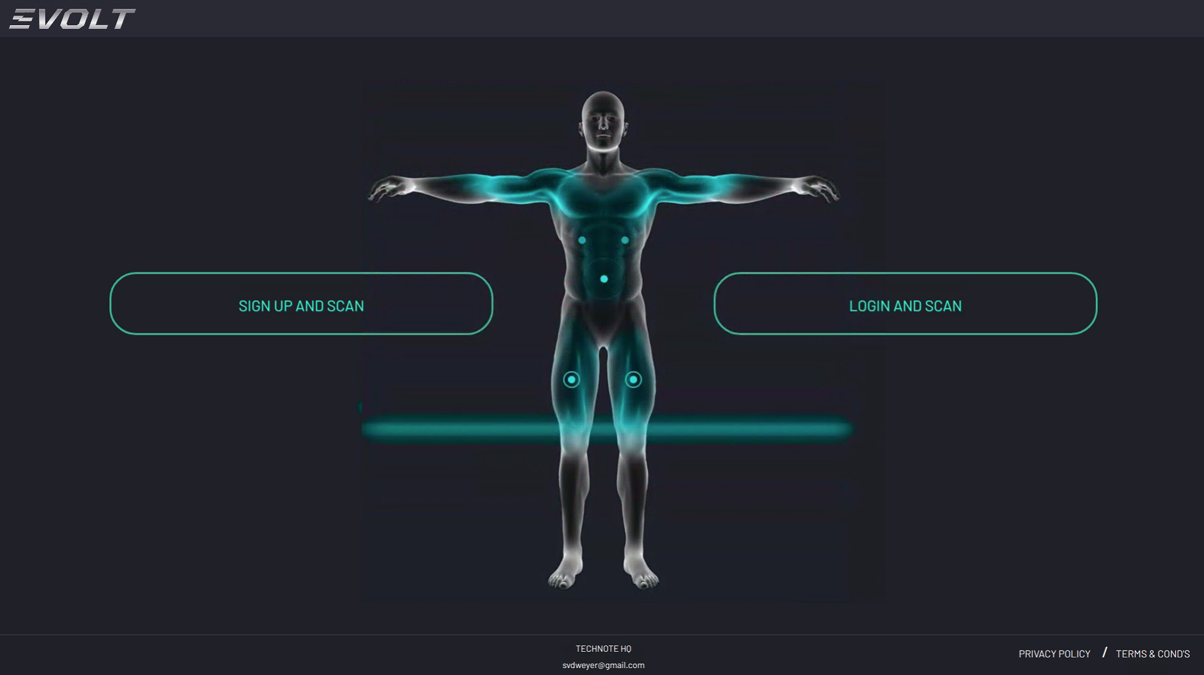

* + 1. If a New Member registration is required, enter the new member's details, pressing NEXT when all fields are populated.

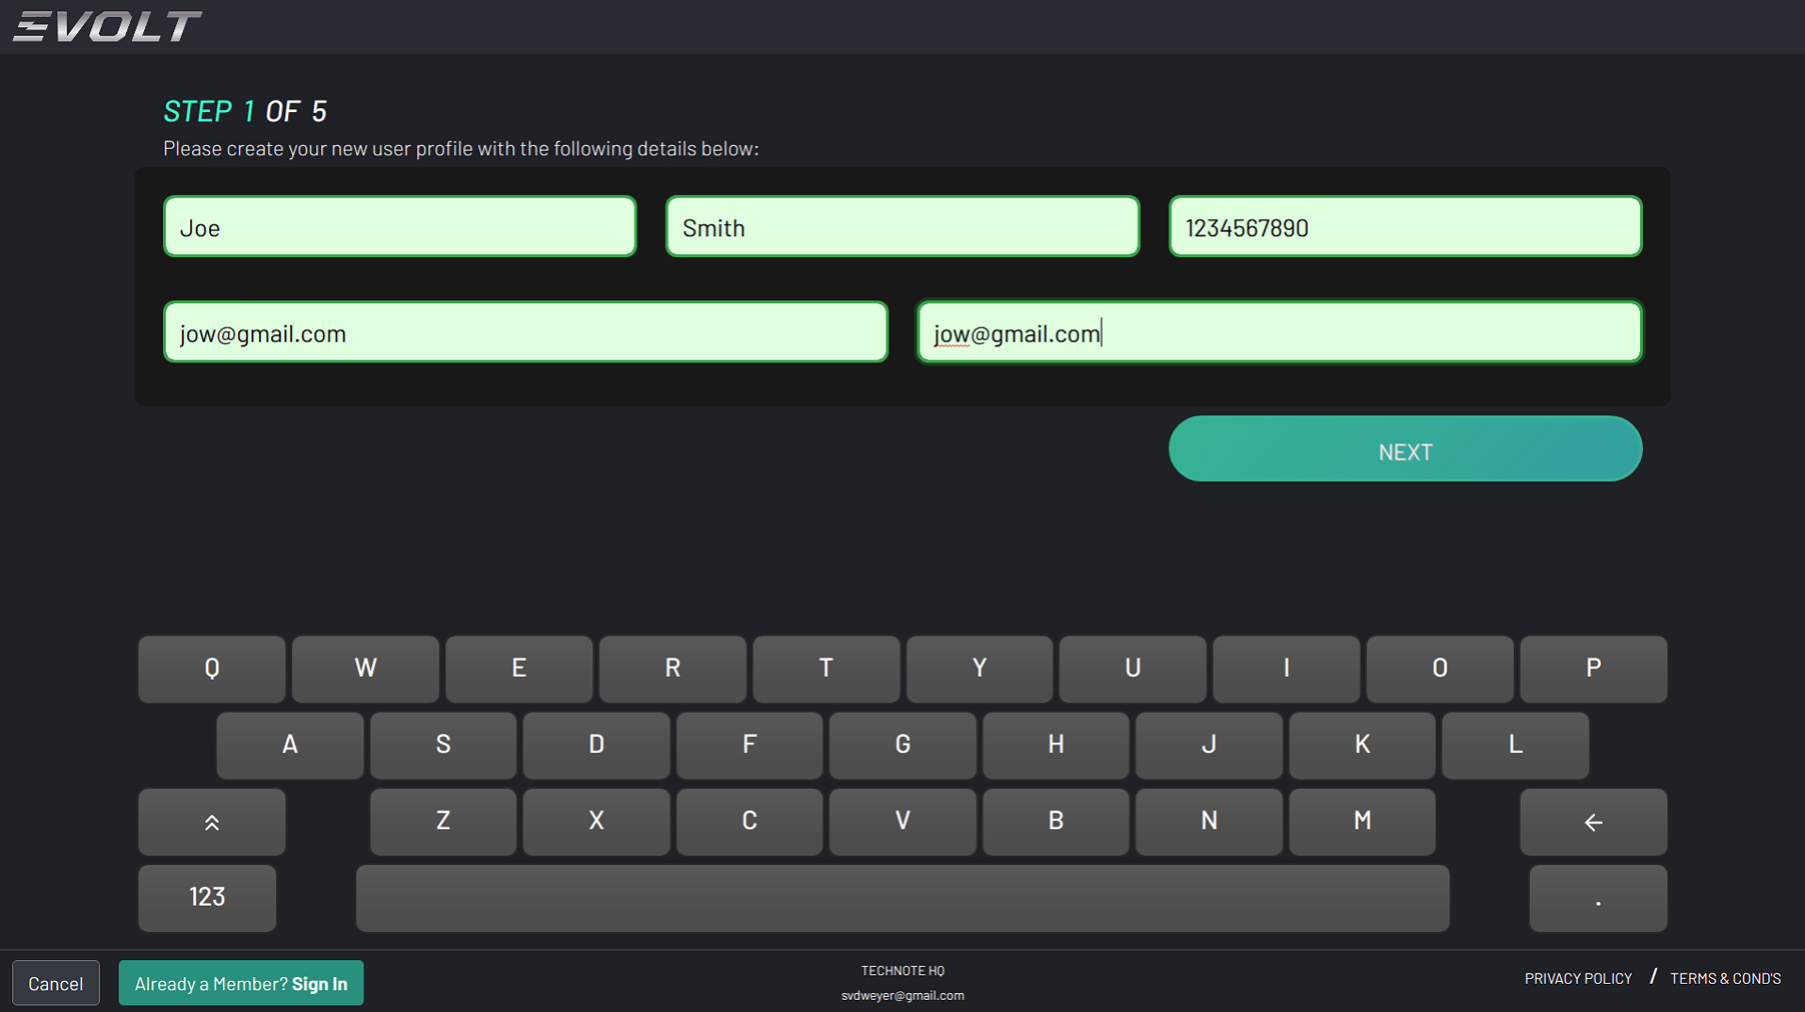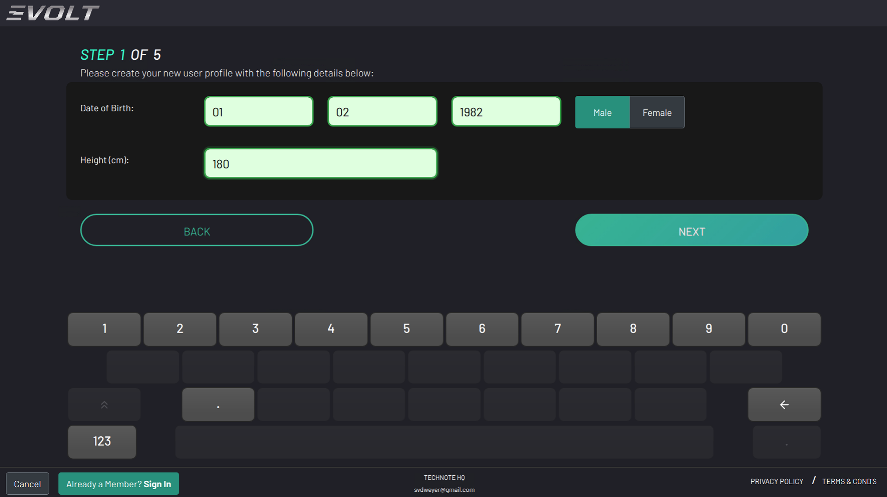

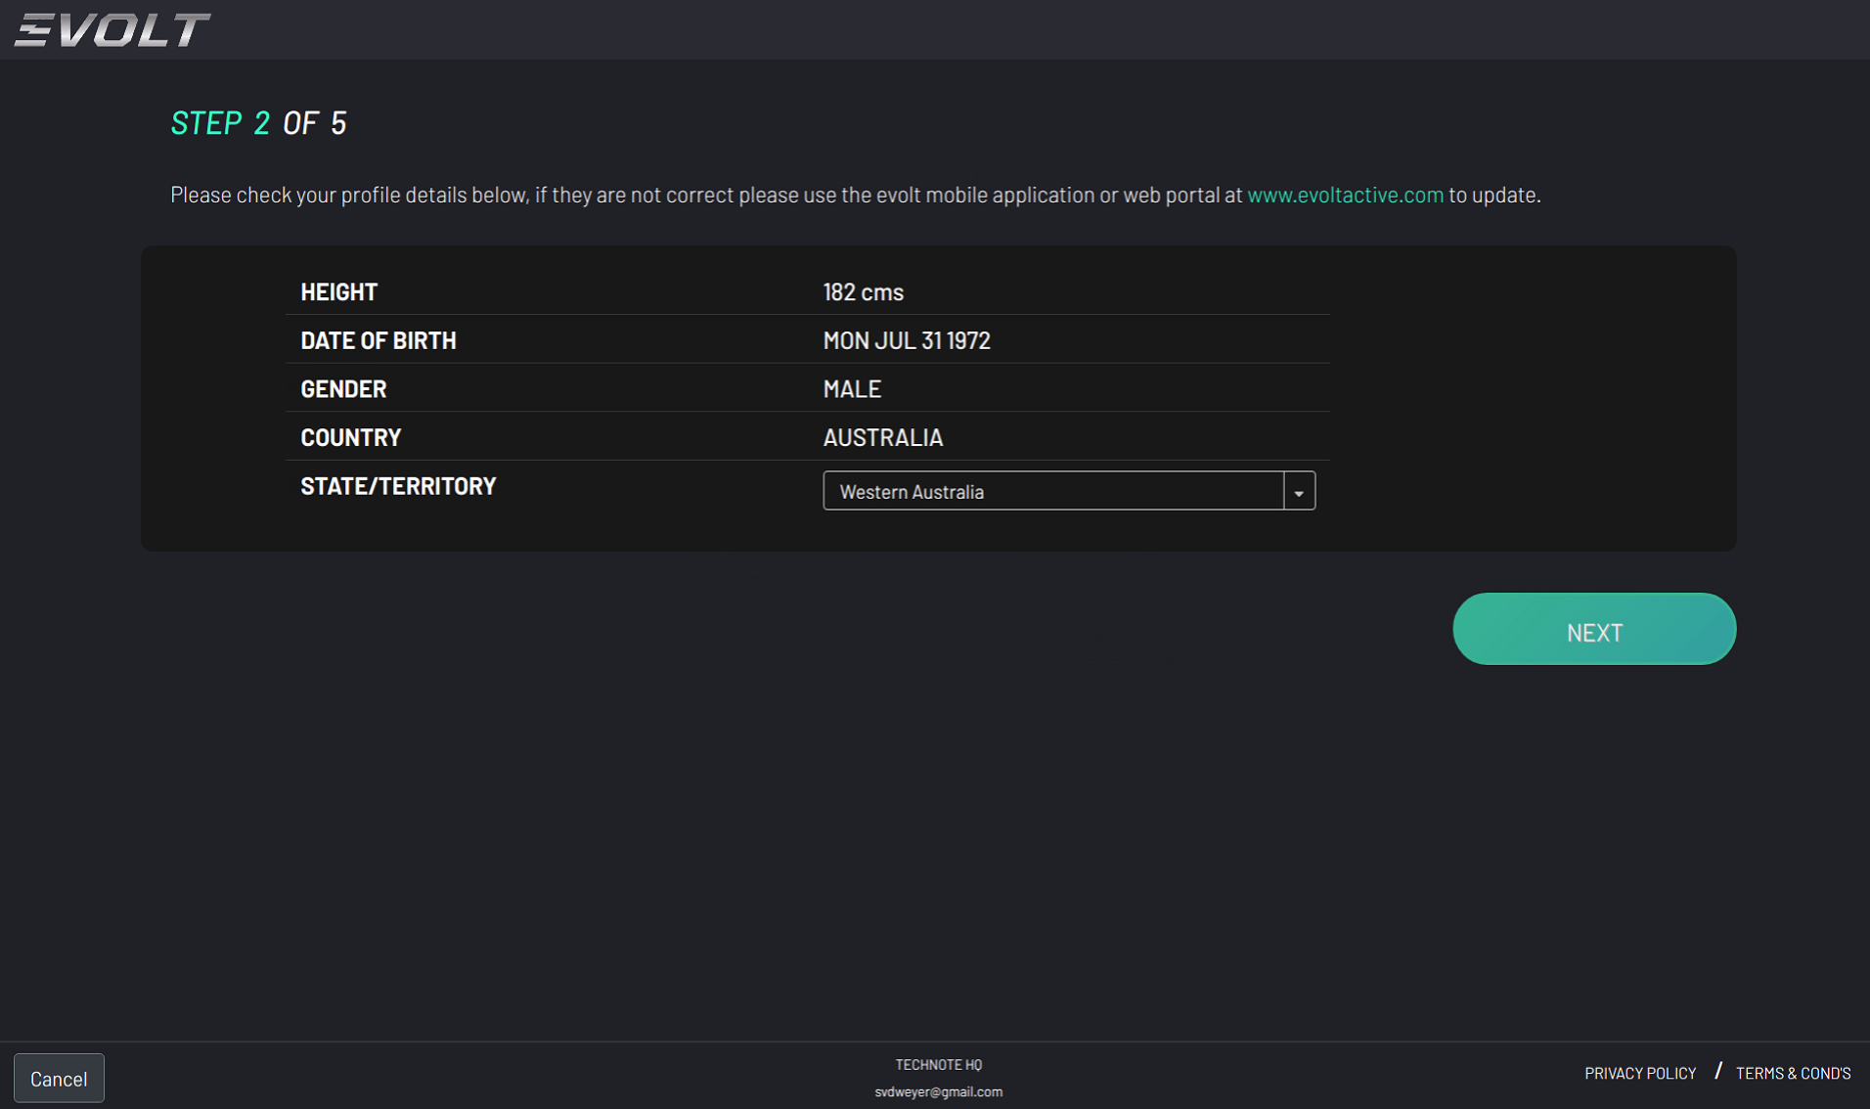

* + 1. Enter new Member Goal details

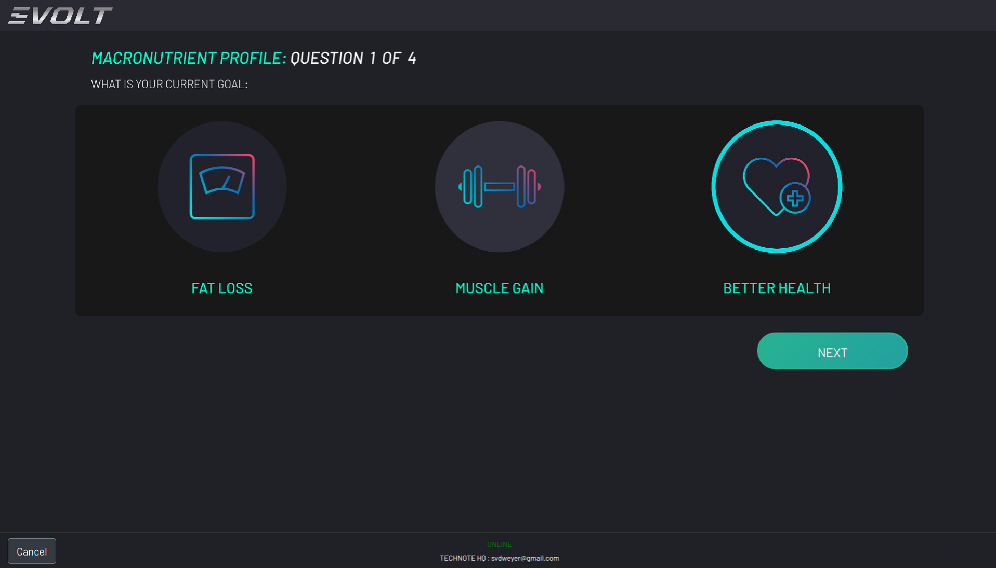

* + 1. Enter new Member Body Type details

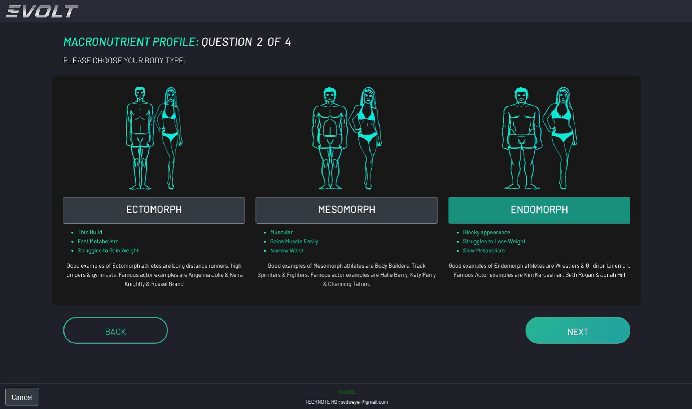

* + 1. Enter new Member activity level details.

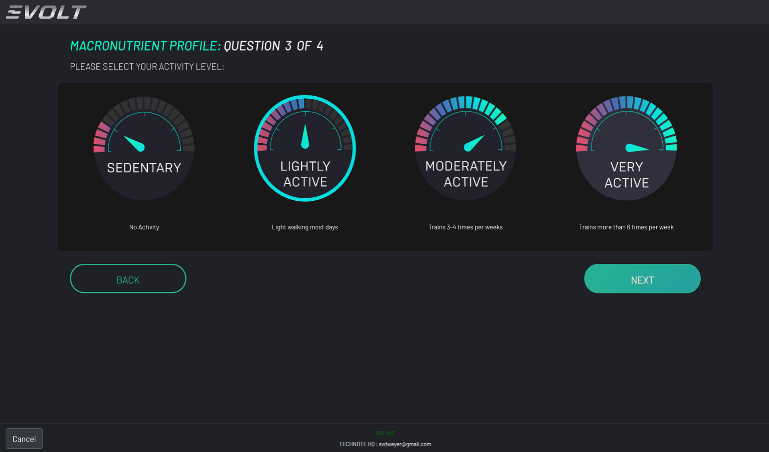

* + 1. Enter new Member activity type details

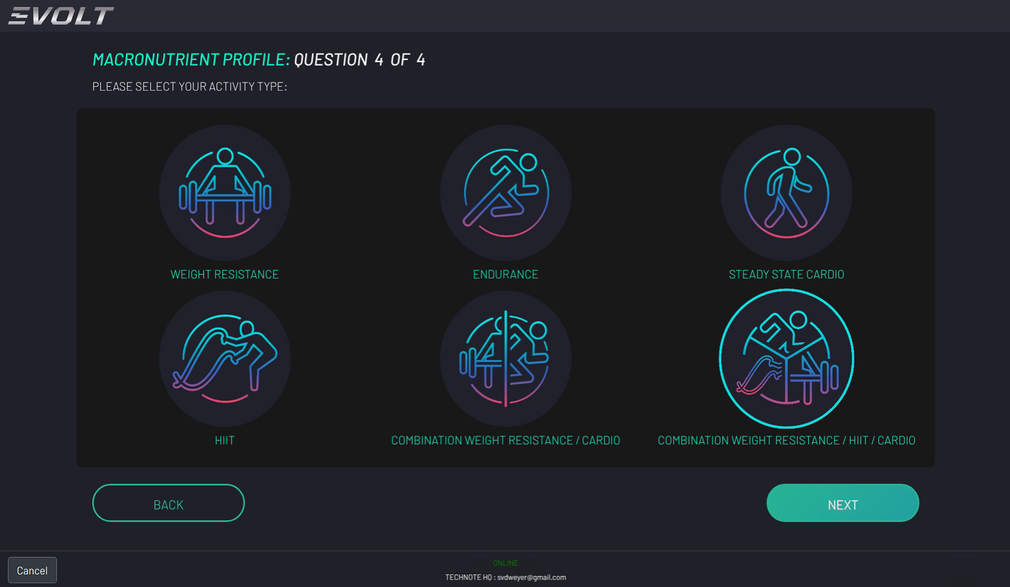

* + 1. Accept Member terms and conditions to continue

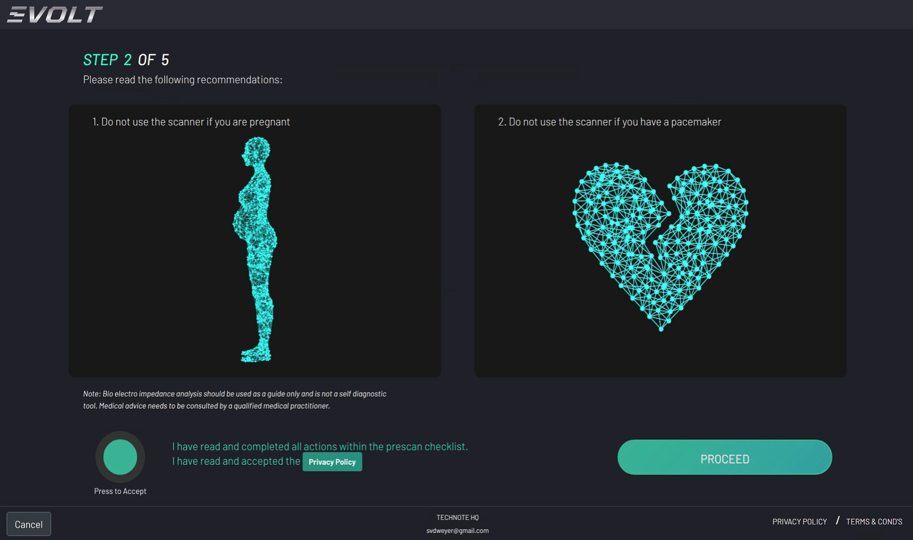

* + 1. Member prompted to stand on the device.

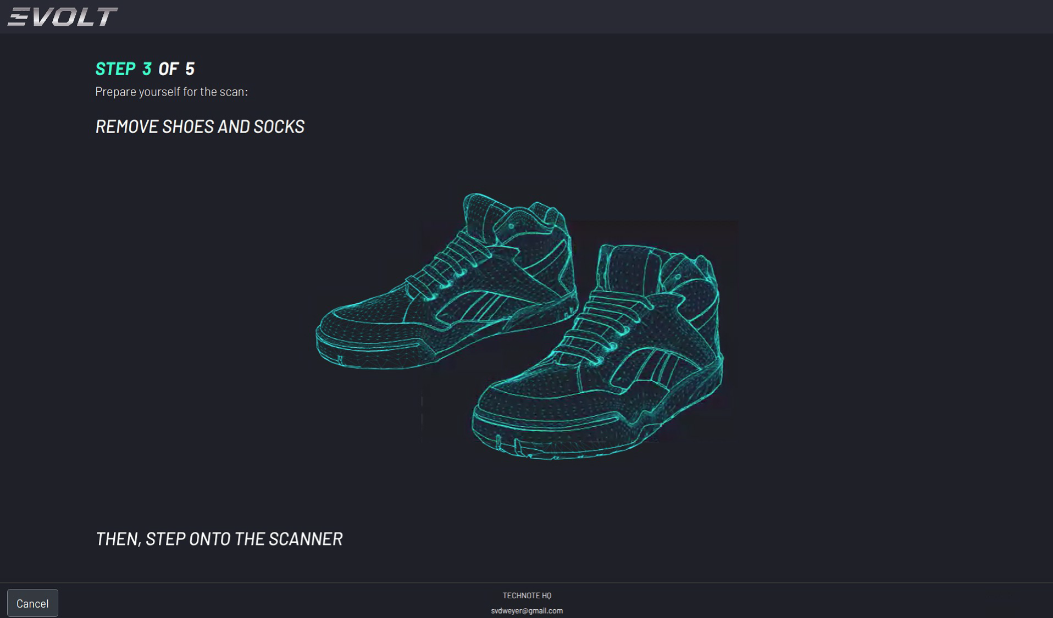

* + 1. Member prompted to make contact with tactile points

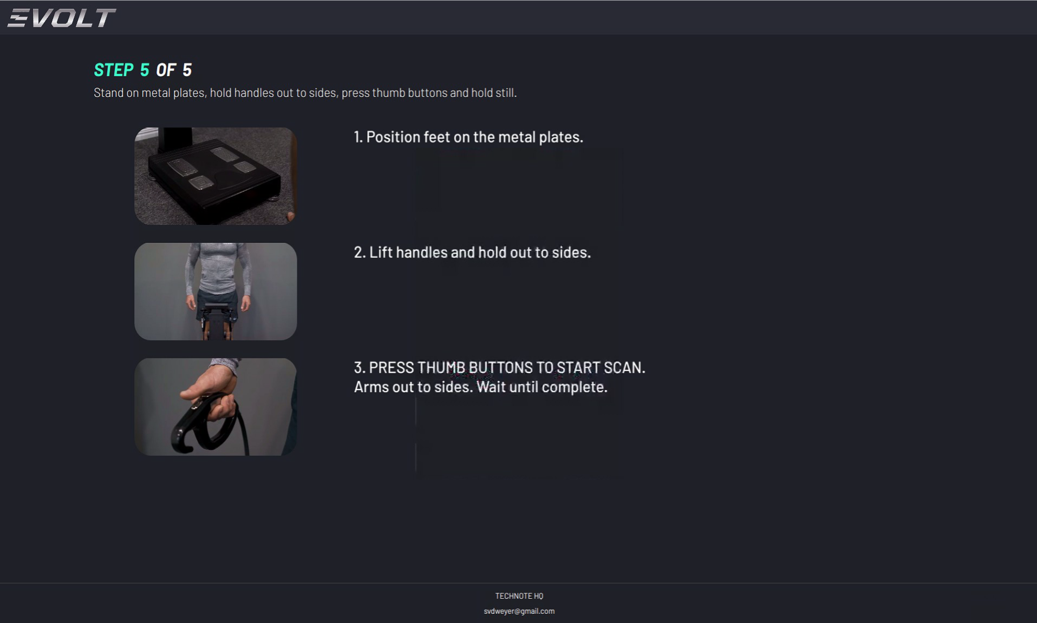

* + 1. Member weighed

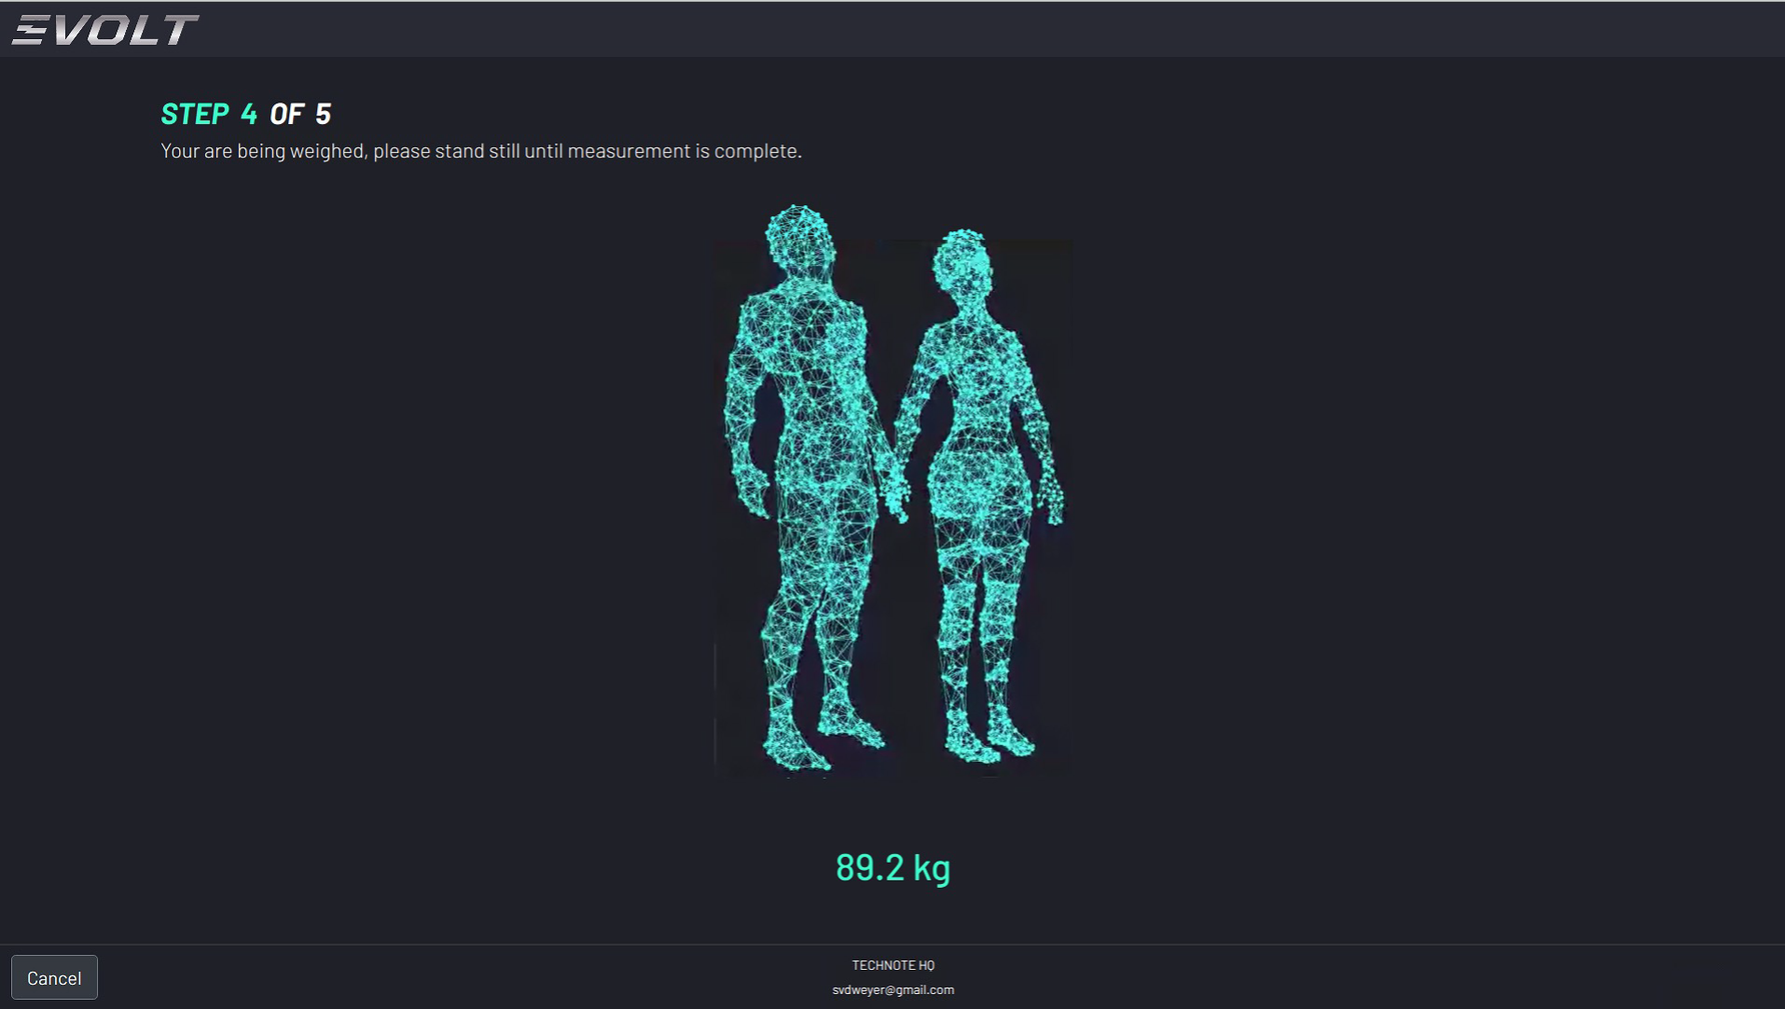

* + 1. Progression shown during scanning

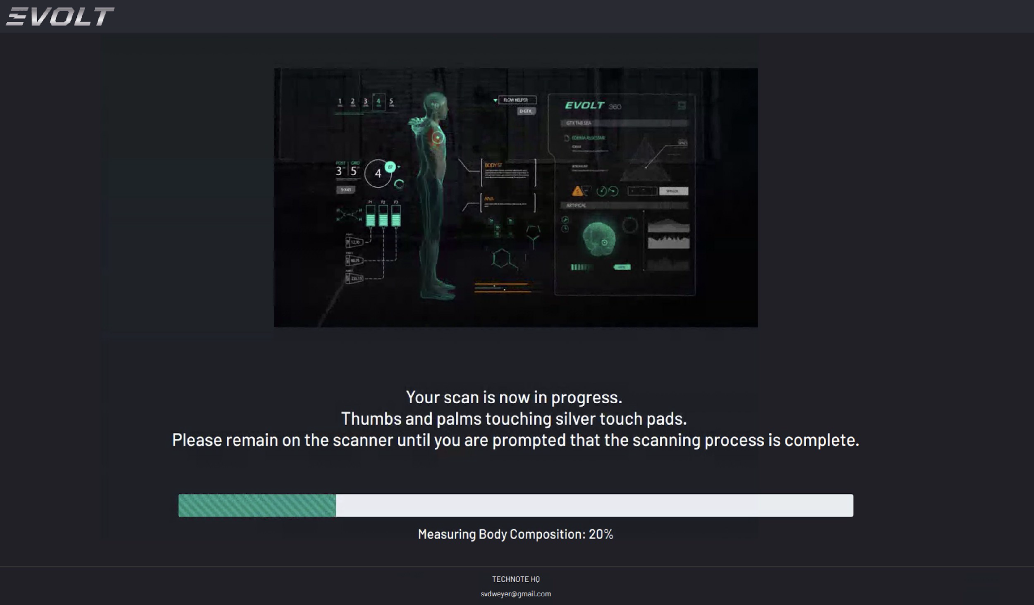

* + 1. Once completed, print out the show.

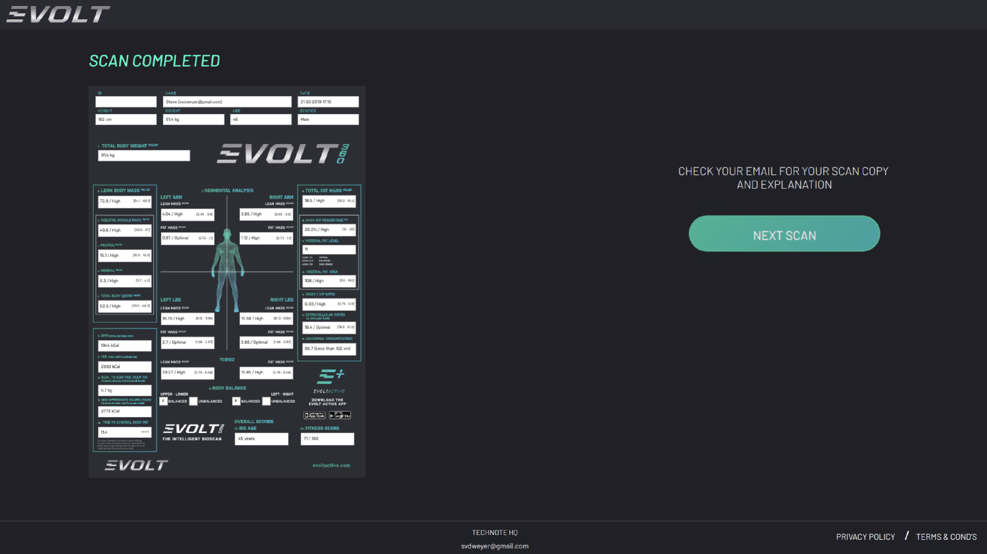

# Kiosk Storage and Maintenance

* + 1. Pay attention to the allowable value of the electric current
    2. Avoid direct sunlight, humidity, dust, thick oil, and salty or extreme changes in temperature.
    3. Do not install or store the device in a place where any chemicals or gases are stored.
    4. Do not use the device in any unstable, vibrating, or impact-giving area.
    5. Do not put or drop anything on the device, and avoid strong impact.
    6. Do not disassemble or remodel the device.
    7. Do not splash any fluid on this device or insert any foreign substances.
    8. If this unit has not been used for a long time, use this after confirming with an expert that all functions and appearance are in good condition.
    9. In case of inserting foreign substances or exposure to a particular environment, this device must be examined by an expert before use.
    10. Use the power cable, plug, and fuse that are offered by our company. At this time, confirm the covering of cable, the state of plug connection, and other checkpoints for the following items.
* RS 232C cable
* USB port
* Adapter
  + 1. When pulling out the power cable, turn off the power switch first and then pull the plug out.
    2. Storage ambient: Temperature -25 ~ 70 °C, Humidity lower than 93 % (non-condensing)
    3. Operation ambient: Temperature 5 ~ 40 °C, Humidity 15 ~ 93 % (non-condensing)
    4. Do not store or use this device under 70 kPa (700 mbar) or over 106 kPa (1060 mbar)of atmospheric pressure.
    5. Cleaning & Disinfection
       - Cleaning: Use a soft gauze cloth with a volatile liquid like alcohol (Ethyl or Isopropyl alcohol 70~90%) to clean it.
       - Clean it every 2~3days. Do not use a wet cloth. Disinfection: After measurement, use a soft gauze cloth with a volatile liquid like benzene and alcohol. Then, wipe the enclosure with a soft lint. Please wipe after every measurement for electrode disinfection.

# Service Desk Tools

## TeamViewer – Remote Access

TeamViewer is a remote access software solution that has been implemented on all kiosk terminals. This software enables users to connect to and control the kiosk terminals from a distance, providing technical support, maintenance, and efficient management of kiosk operations.

### Accessing TeamViewer

* + 1. Begin by navigating to the official TeamViewer website at https://www.teamviewer.com. This is the central hub for downloading the application safely and securely.
    2. Once on the website, locate the prominent 'Download' button that corresponds to your operating system, whether it's Windows, macOS, or Linux. Click on this button to initiate the download process.
    3. After the download is finished, locate the installer file in your downloads folder or on your desktop, and double-click it to open. Follow the on-screen instructions provided by the installation wizard to successfully install TeamViewer on your device.
    4. Once the installation is complete, you can find TeamViewer either on your desktop or in your start menu. Click the TeamViewer icon to launch the application.
    5. As the application opens, you will be prompted to sign in. Enter your credentials using the appropriate TeamViewer account associated with the email address customer.support@evolt360.com.
    6. If this is your first time accessing your TeamViewer account, the system will likely require you to validate your device for security purposes. To do this, check your inbox for an email sent to customer.support@evolt360.com and follow the provided instructions to complete the validation process. This step ensures that your account and device are securely connected.

### Connect To a Remote Computer

1. Ask the person you want to connect to for their TeamViewer ID and password.  
2. Enter their ID in the 'Partner ID' field and click 'Connect'.  
3. When prompted, enter the default Evolt device password as recorded in LastPass.  
4. You will now be connected to their computer and can control it remotely.

If the default password does not work, refer to section XX.

## Microsoft Outlook

The two support accounts are configured with associated mailboxes that are actively monitored to manage incoming support tickets, ensuring timely tracking and response to customer issues. The mailboxes serve both as a communication channel for client interactions and as a notification hub for ticket updates. To access the email, follow the steps below.

1. Open a web browser.
2. Go to [**https://outlook.office.com**](https://outlook.office.com)
3. Enter your Microsoft 365 email address and click **Next**.
4. Enter your password and click **Sign in**.
5. If prompted, complete the **Multi-Factor Authentication (MFA)** process
6. Once logged in, you will be taken directly to your Outlook inbox, where you can view, send, and manage your emails.

## Microsoft Teams

Microsoft Teams is currently utilised as the primary communication portal between both Evolt and Asta, serving multiple critical functions. It facilitates the efficient management of escalations, allowing urgent issues to be raised, tracked, and resolved promptly. Teams is also used for the posting and sharing of shift reports, ensuring that all relevant stakeholders have access to up-to-date information regarding operational activities, incidents, and performance metrics. Additionally, the platform supports general conversations and collaboration, enabling seamless communication between teams across locations, promoting transparency, and fostering a collaborative environment

1. Open a web browser (e.g., Chrome, Edge, Firefox, or Safari).
2. Navigate to **https://teams.microsoft.com**.
3. Enter your Microsoft 365 email address and click **Next**.
4. Enter your password and select **Sign in**.
5. If prompted, complete the **Multi-Factor Authentication (MFA)** process
6. Once authenticated, you will be redirected to the Microsoft Teams web interface.
7. From here, you can access chats, teams, channels, meetings, and files directly from your browser.

## HubSpot

### Overview

Evolt utilises HubSpot as its Customer Relationship Management platform that brings together sales, marketing, customer support, and operations into a single, integrated system. It provides tools for managing customer relationships, tracking sales pipelines, running marketing campaigns, handling support tickets, and automating routine processes, all while keeping customer data centralised and accessible across teams. , gain visibility into performance, and deliver a consistent, high-quality customer experience.

### Accessing the Ticketing System

The Evolt HubSpot environment is integrated with the Evolt M365 environment for logging into the system. To access the environment, please follow the steps below:

1. Open your web browser and go to <https://app.hubspot.com/login>.  
     
   
2. On the login page, enter either of the customer support email addresses and press **NEXT**

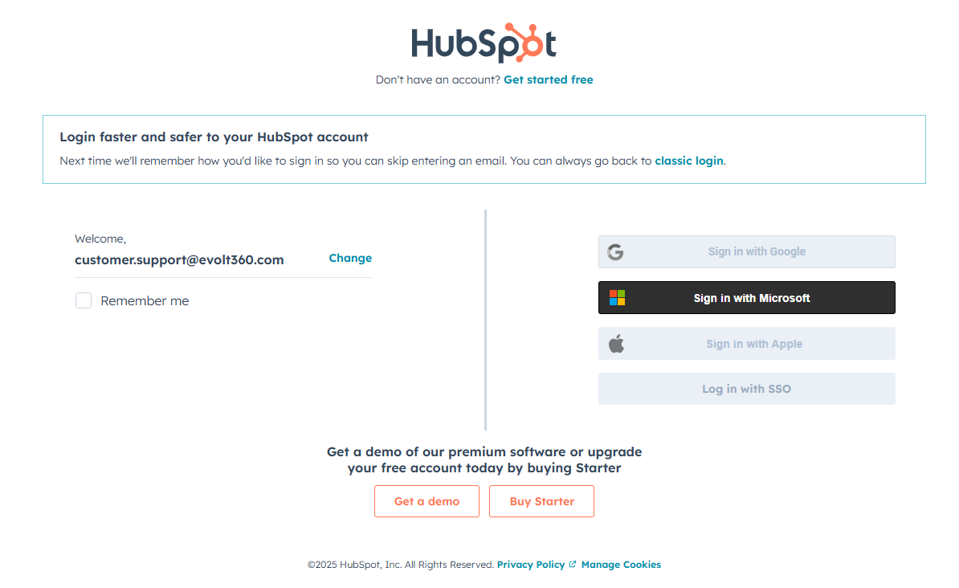

1. Once pressed, this should highlight and allow for the selection of **“Sign in with Microsoft”**.
   1. If you have not logged in before, you will need to add the Evolt account to your list.  
      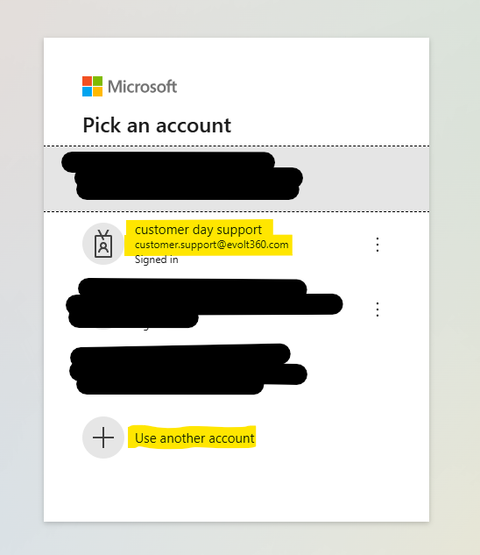
   2. Add a new account and enter the Evolt details.
   3. Enter your Microsoft account password. (Find in LastPass)
2. The system will then prompt to validate the email against M365. Enter your Microsoft (Office 365 / M365) email address and click **Next**.
3. Select the Evolt account and next until you are prompted to enter the MS Code  
   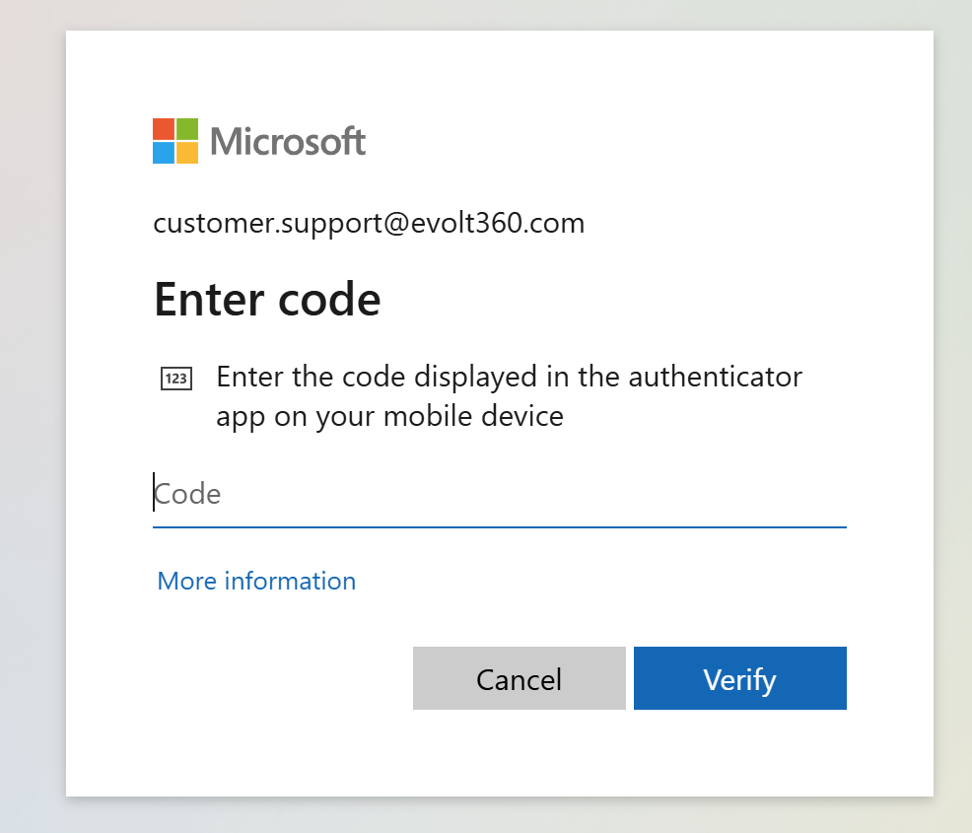
4. M365 will then require MFA authentication, which has been configured and assigned to Text It <https://textit-prod.azurewebsites.net/>
5. Use your Asta account to access the Text Its website
6. Select the TOTP Tokens on the left navigation

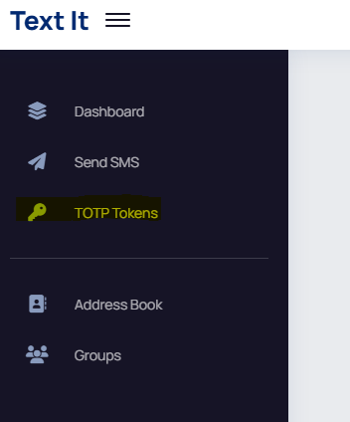

1. Search for Evolt and enter the code displayed for the matching account.

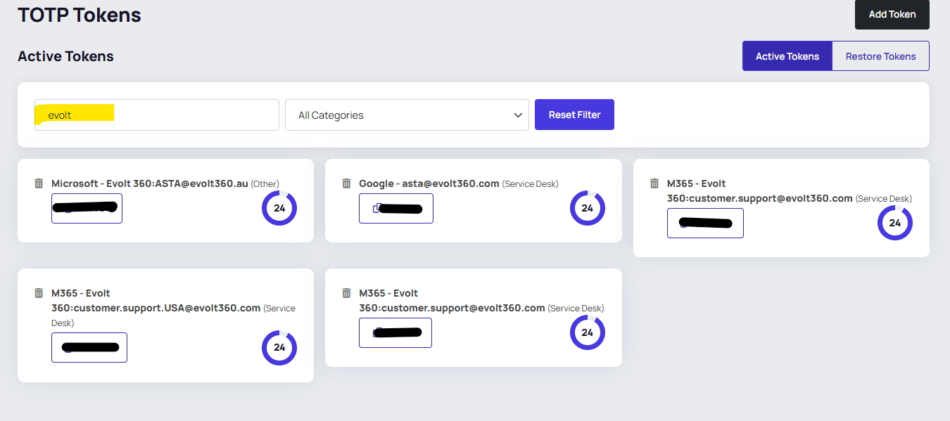

1. When prompted to configure the MS Authenticator App, press **SKIP NOW**
2. Once authenticated, you will be redirected back to HubSpot, where you may be prompted to enter a code. HubSpot will have sent this to the customer support email

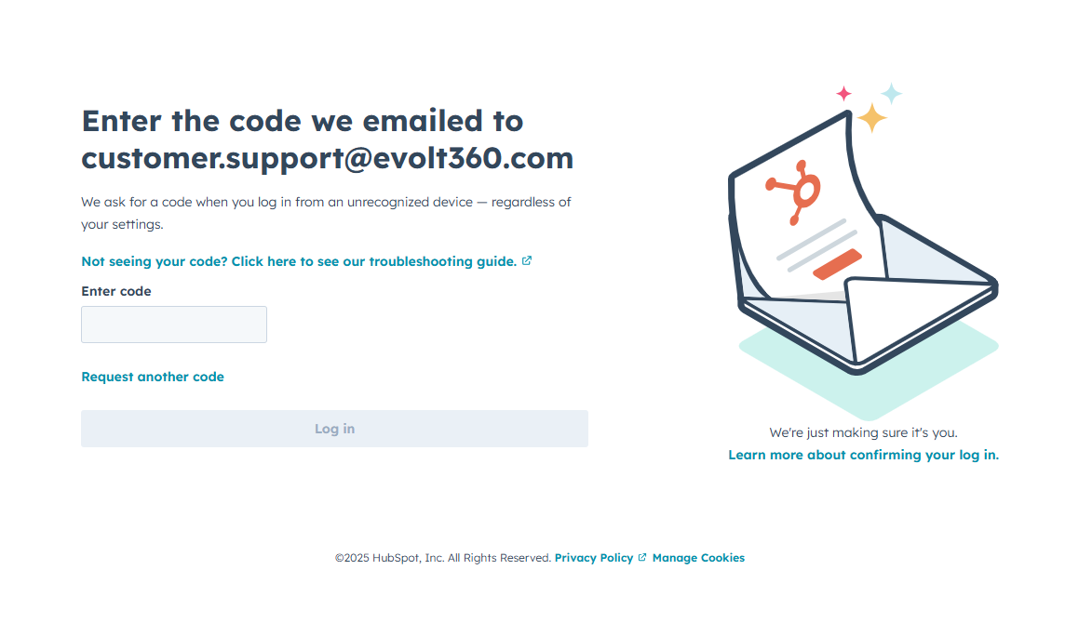

1. Log in with. Via Outlook, retrieve this code.
   1. Outlook.office.com
   2. Enter/pick the account [customer.support@evolt360.com](mailto:customer.support@evolt360.com)
   3. Use LastPass to retrieve the password
   4. When prompted for the MS Account code, use Text It to copy the code and paste it for the MFA.



* 1. Open the recent email and copy the details for the HubSpot code.

1. The email will appear. Simply copy the code and paste this into the required field.
2. Skip setup for Authenticator

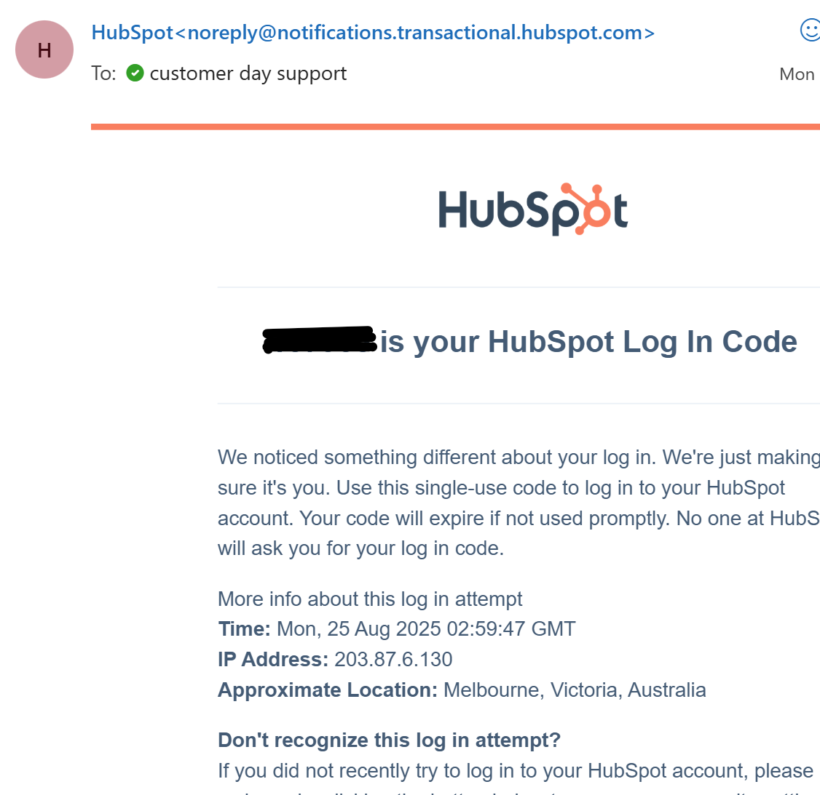

**Note:** If you are already signed into your Microsoft account in the browser, HubSpot will log you in automatically.

Once logged into the main dashboard, hover over the CRM tab on the left and navigate to Tickets. This is your ticketing system, and where you can view, change, and action ticket queries.

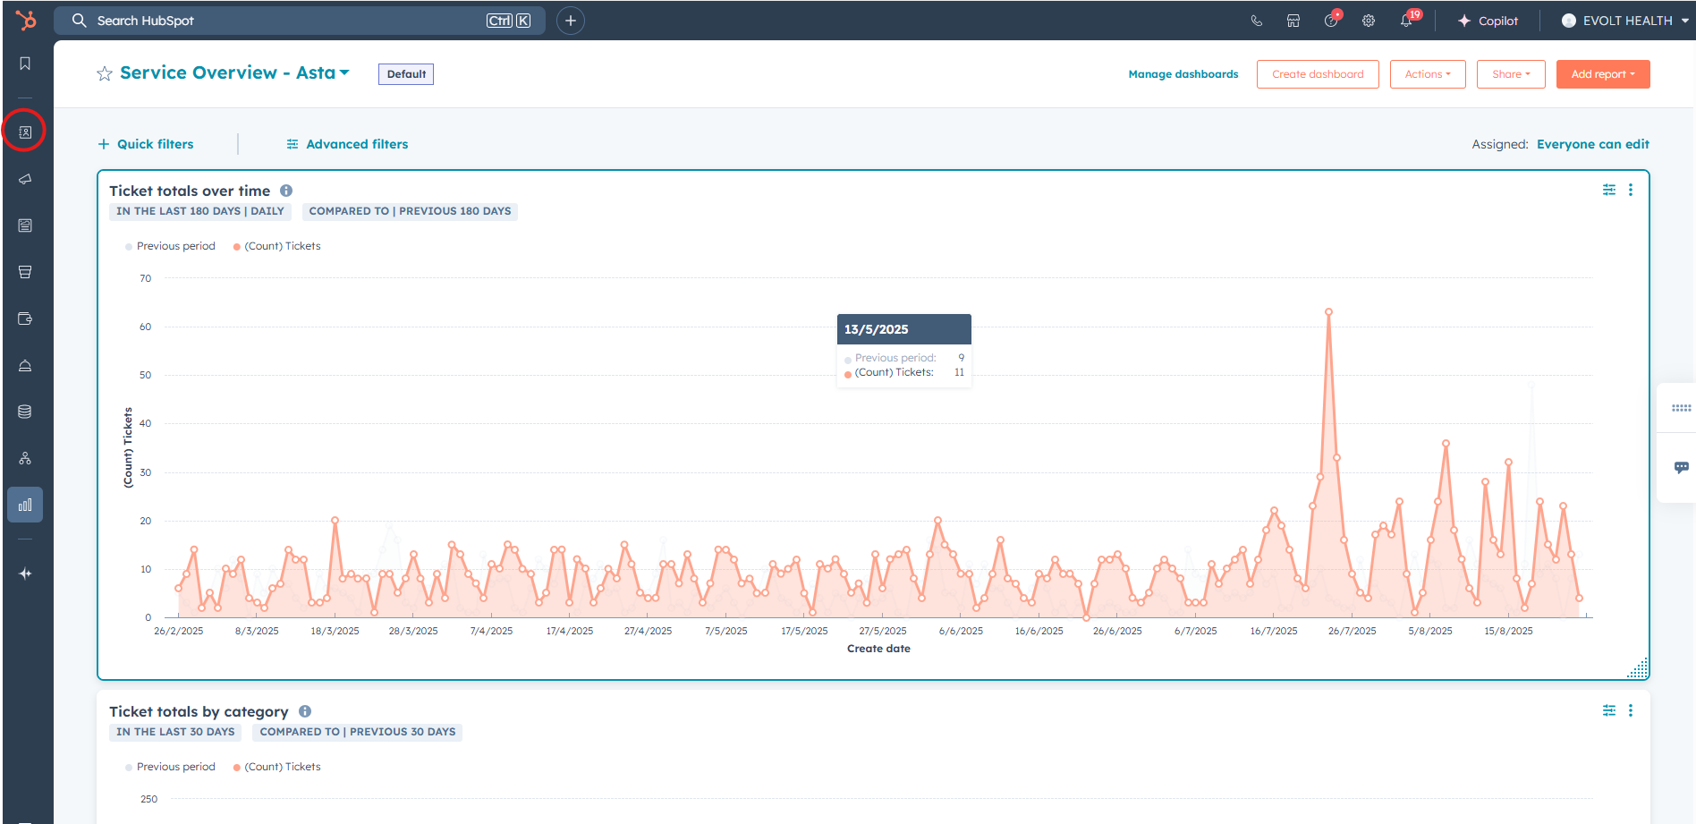  
  
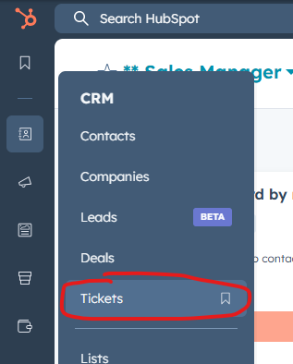

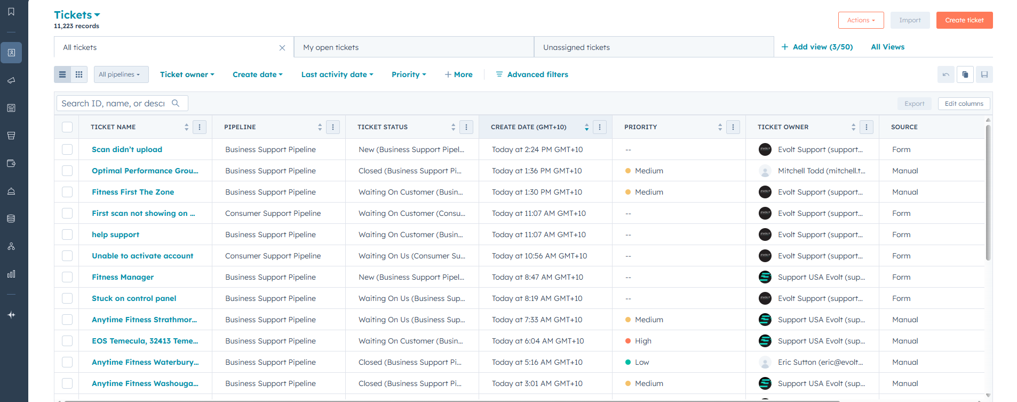  
This is the main ticket management menu. This is where Service Desk can track progress, manage, and create new tickets.

### Ticket Service Level Agreements

|  |  |  |  |
| --- | --- | --- | --- |
| **Severity​** | **Response SLA​** | **Resolution SLA​** | **Measurement Period​** |
| **Priority 1​** | 15 Minutes Response ​ | 2 Hours​ | Monthly​ |
| **Priority 2​** | 1 Hour Response ​ | 4 Hours​ | Monthly​ |
| **Priority 3​** | 4-Hour Response ​ | 2 Business Days​ | Monthly​ |
| **Priority 4​** | 1 Business Day​ | 4 Business Days​ | Monthly​ |

### Incident Priority Matix

|  |  |  |  |  |  |
| --- | --- | --- | --- | --- | --- |
| Incident Priority Matrix | URGENCY | | | | |
| **Critical (P1)** | **High**  **(P2)** | | **Medium**  **(P3)** | **Low**  **(P4)** |
| **Critical (P1)**  An outage is impacting all Evolt 360 customers globally, preventing the end-to-end use of the Evolt 360 Platform. | P1 | | P2 | P3 | P3 |
| **High (P2)**  An outage impacting a major Evolt 360  Customer or many Evolt 360 customers globally, of a service that prevents the end-to-end use of the Evolt 360 Platform | P2 | | P2 | P3 | P4 |
| **Medium (P3)**  Significant customer/service/product-  specific issue across multiple (>10) sites | P3 | | P3 | P3 | P4 |
| **Low (P4)**  An issue that is isolated to a single site,  user or device | P3 | | P4 | P4 | P4 |

### Creating a New Ticket

A new ticket must be created for every call or email received. All mandatory information, listed below, should be included to ensure consistency, proper categorisation, and effective follow-up, while providing necessary context for team members and supporting timely resolution.

|  |  |
| --- | --- |
| **Field Name** | **Description** |
| Ticket Name | A concise but clear summary of the issue. E.g. “Staff Kiosk Not Logging In” or “Wi-Fi Connectivity Issue in Level 3 Meeting Room.” |
| Pipeline | Select the appropriate pipeline (e.g., IT Support, Facilities, etc.) |
| Ticket Status | Choose the initial status e.g., New, Waiting on User, In Progress, Escalated). |
| Type | Business or Consumer only |
| Country | Requester’s current location. |
| Create Date | Ticket creation date |
| Issue Category | Used to define the nature of the request (e.g., Hardware > Printer Issue, Software > Login Failure |
| Support Category | Enter the relevant support type. |
| Within Warranty | Yes/No/N/A Consumer |
| Ticket Origin | Indicate how the ticket was raised (e.g., Email, Phone, Walk-in, internal note). |
| Ticket Owner | By default, this should be set to Support Team AU Day. |
| Ticket Technician | Useful for routing or identifying who the ticket is for. |
| Ticket Description | Expand on the Ticket Name field with a 1-2 sentence description. |
| Priority | Select based on impact and urgency (e.g., Low, Medium, High, Urgent) |
| Contracts | Links a ticket to a specific location or user account, usually by entering the email address of the gym or requester. For example, if someone from the Port Washington, WI gym raises a ticket, this field helps connect the issue to that site location. It allows the service desk to track historical tickets, identify recurring problems, and provide better support through |

1. Create a ticket by selecting the plus button then ticket  
    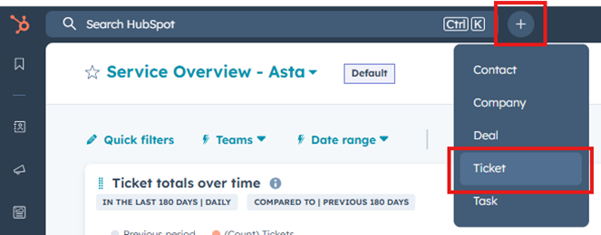

Or by selecting CRM – ticket – create ticket

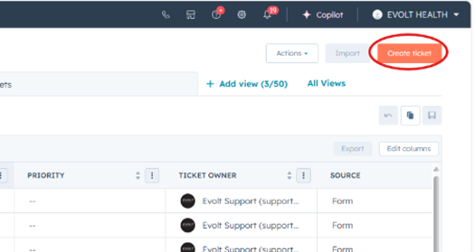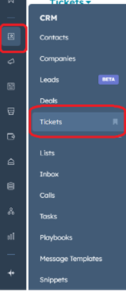

1. This will open the ***New Ticket*** menu, where mandatory and optional fields can be filled out before saving.

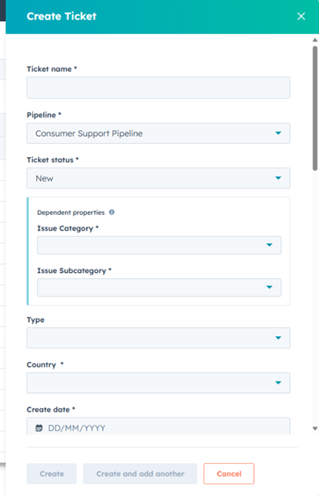

1. If the user is calling from a business, bring up the Company in the CRM, identify the machine, and create a ticket for Business Pipeline calls

This can be located through the CRM/Companies

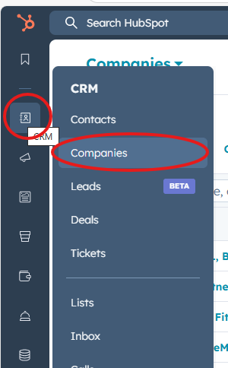

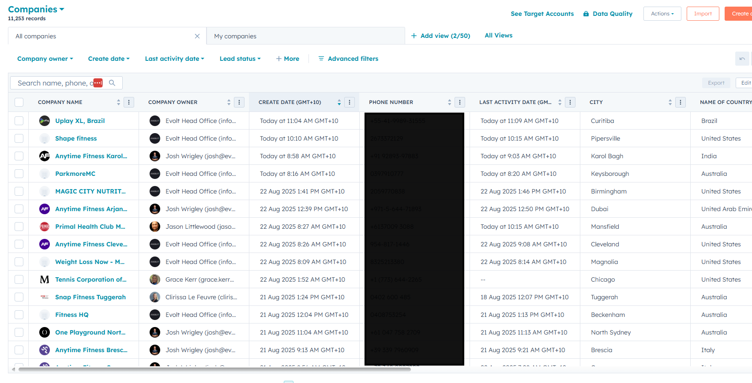

1. Select the Company Name
2. Select the “Machine” in Deals on the right-hand side. This is needed for the validation of the warranty.

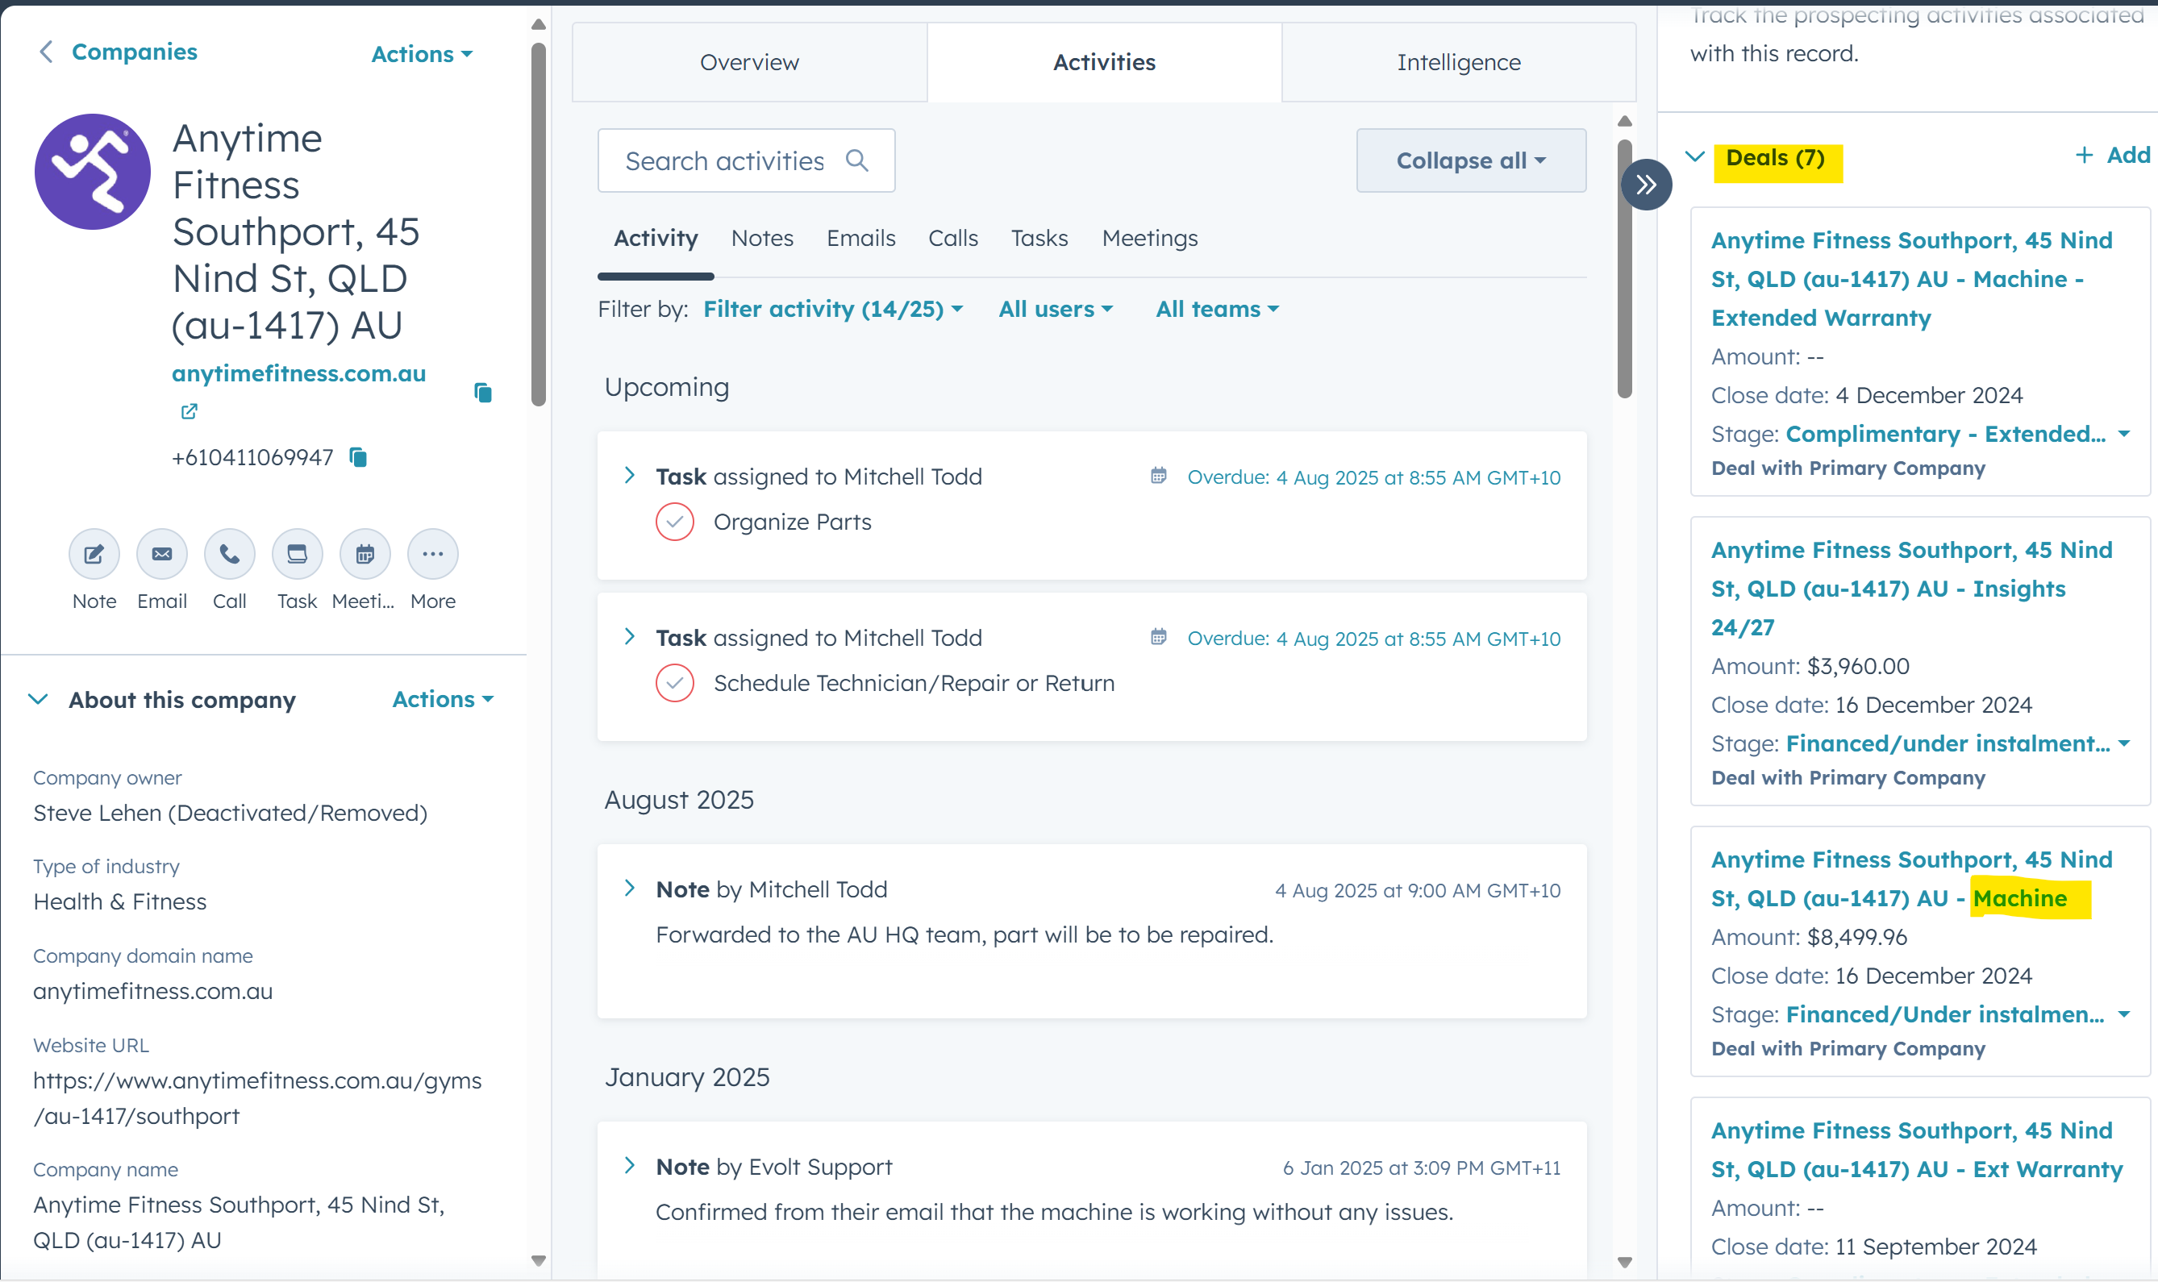

1. Scroll down on the right-hand side until you see Tickets and Select **Add**

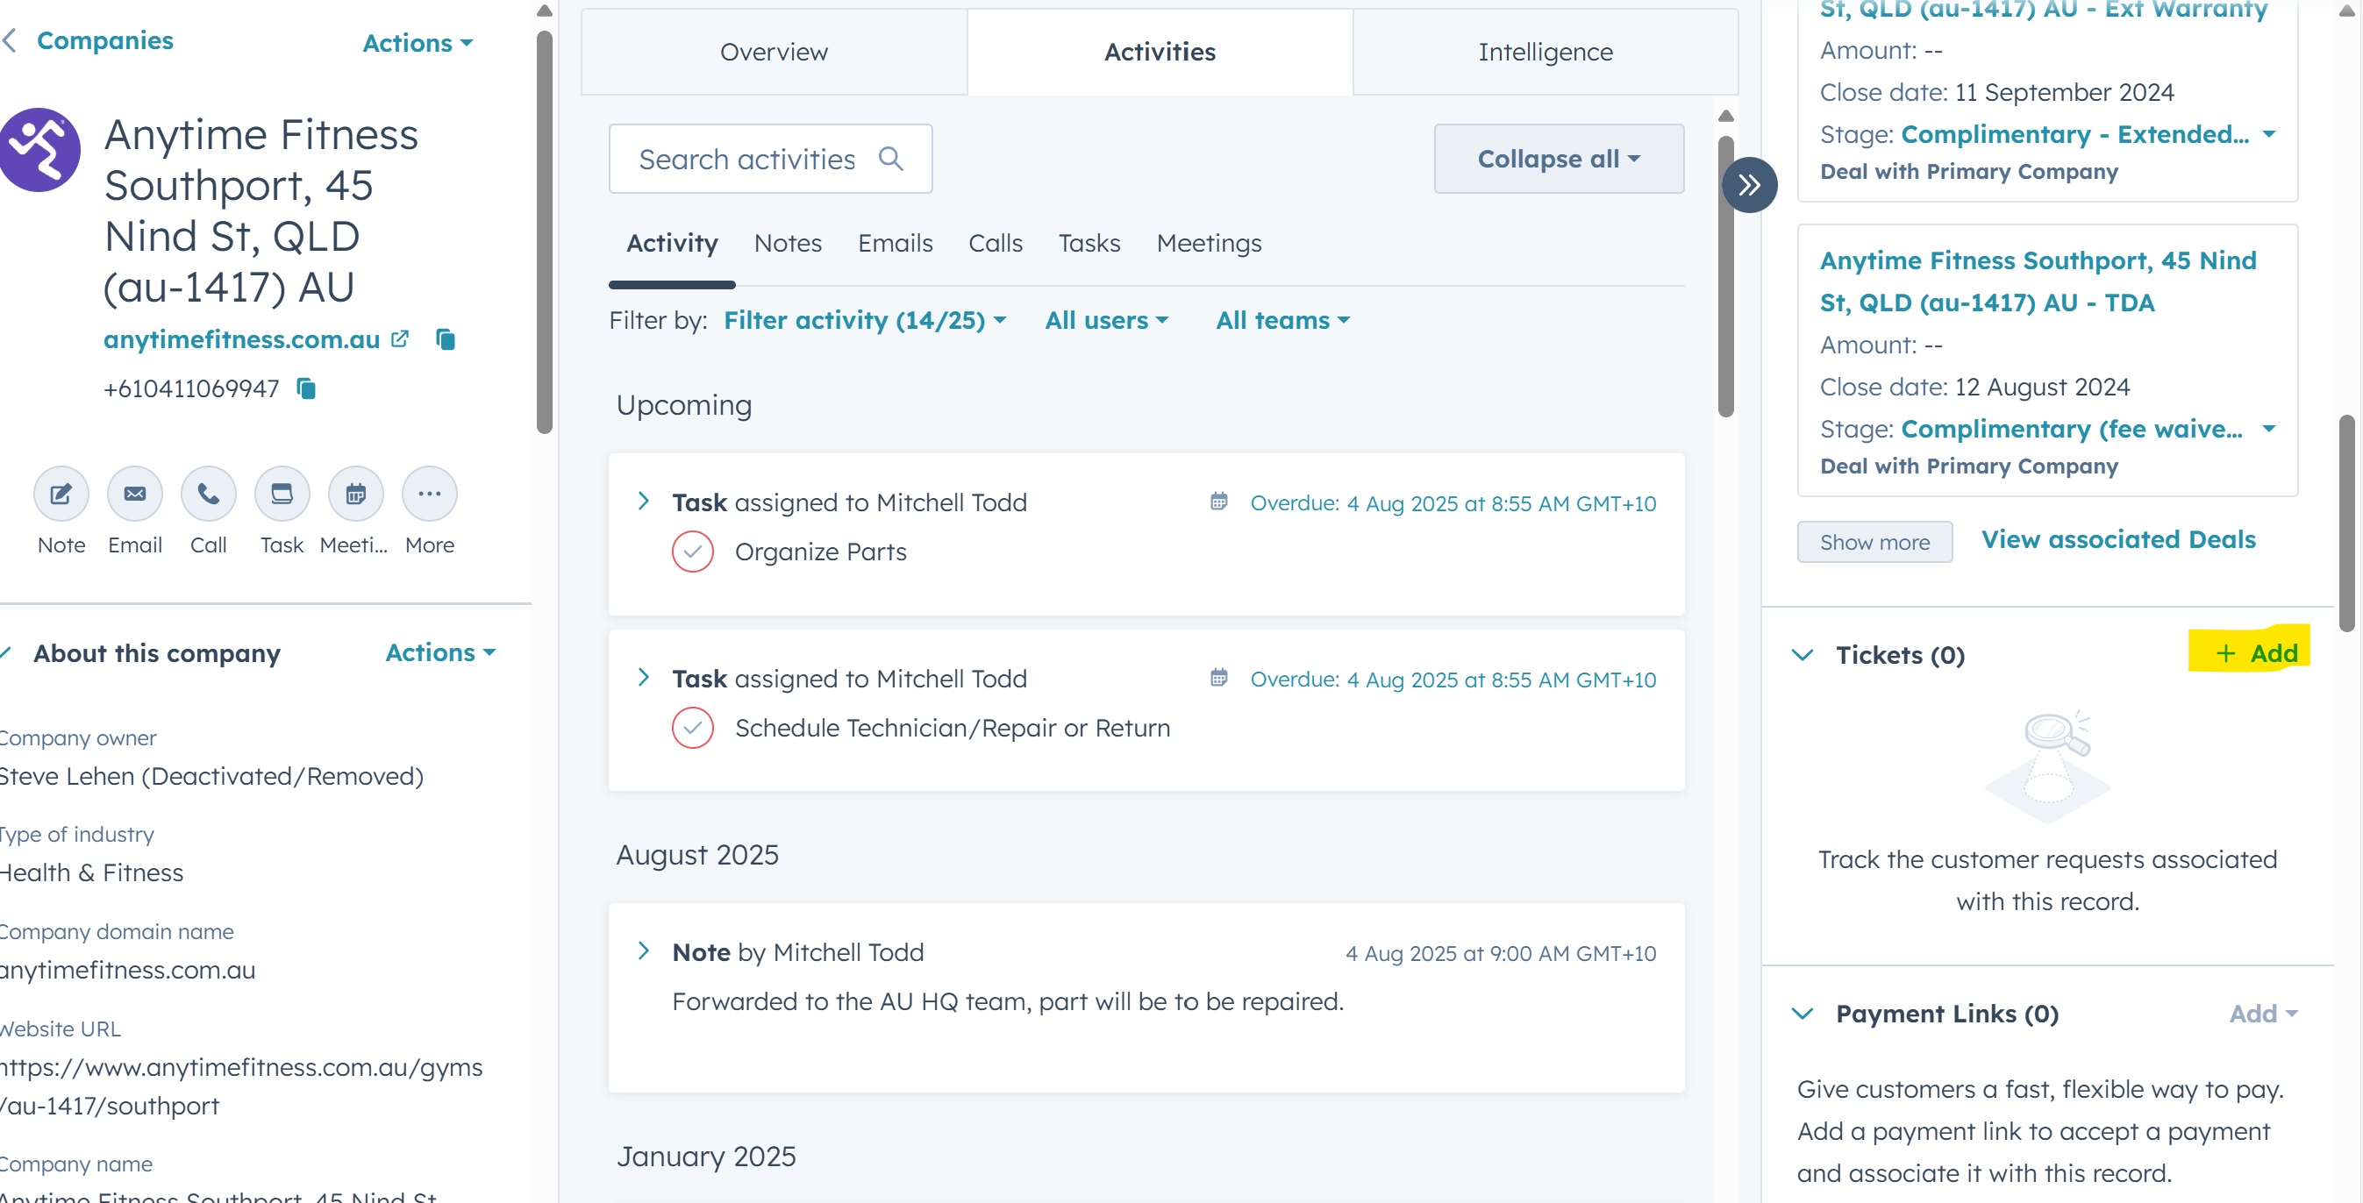

1. Add a brief description to complete the Ticket Name
2. Select the Pipeline:
   1. Consumer Support Pipeline – public using the Evolt equipment, e.g., can't retrieve scan, how do I register
   2. Business Support Pipeline – The gym or business that owns the Evolt equipment, e.g., Anytime Fitness
3. Ticket Status – New
   1. See table below for status descriptions
4. Select the Issue Category based on the model or application-specific issue that is related to the ticket. The model number can be seen in the CRM profile for the company's Machine

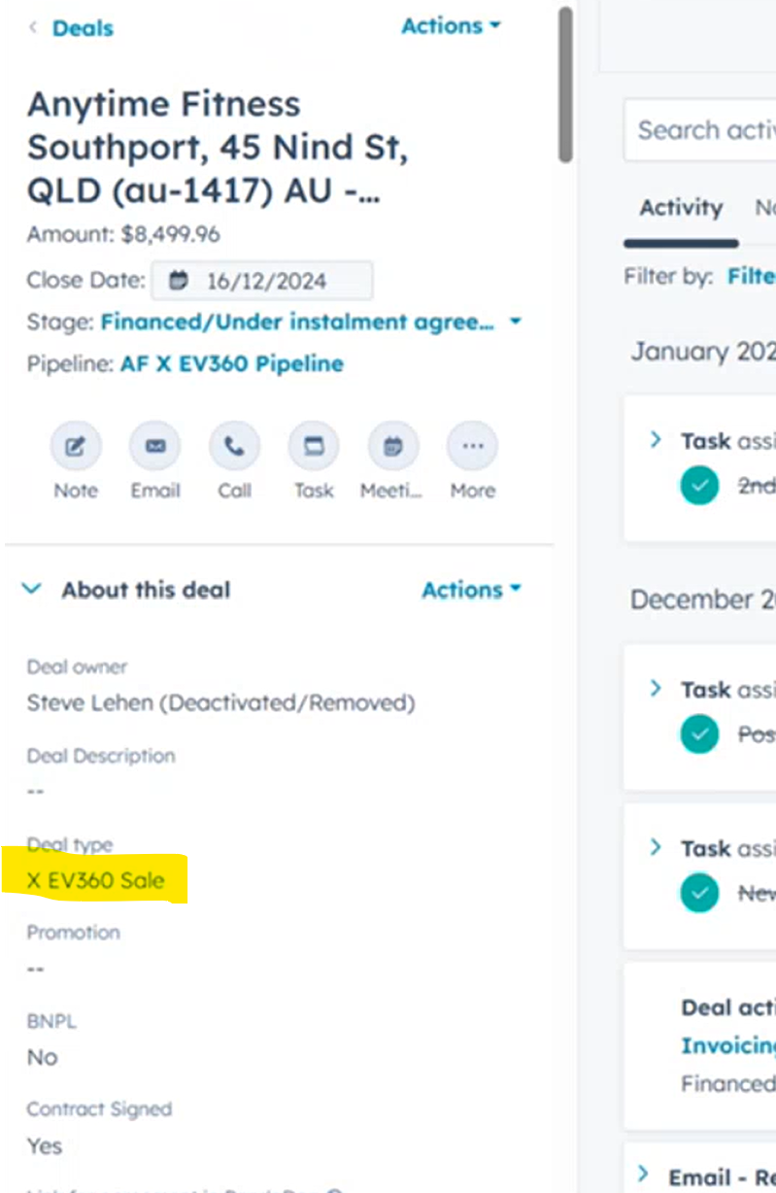

1. Multiple Categories can be selected.
2. Select the Subcategory based on the selected Category
   1. The Category and Subcategory can be updated later once the issue is specifically identified.
   2. Multiple items can be selected.
   3. Based on the selected items, additional fields may be shown. E.g., hardware, software
3. **Hardware Issue:**  Select the hardware issue if unsure. Select “Other ”; otherwise, select the most likely hardware issue
4. Within warranty
   1. This can be located under the company and the “Deals” on the right-hand side of the screen, look for “Machine”

e.g. 

* 1. Scroll down on the left to see their subscription and warranty details

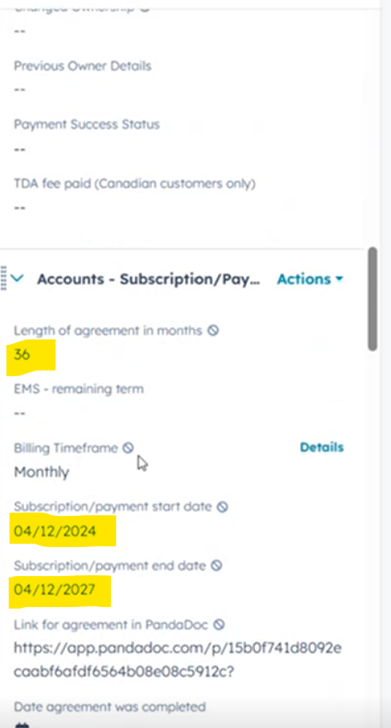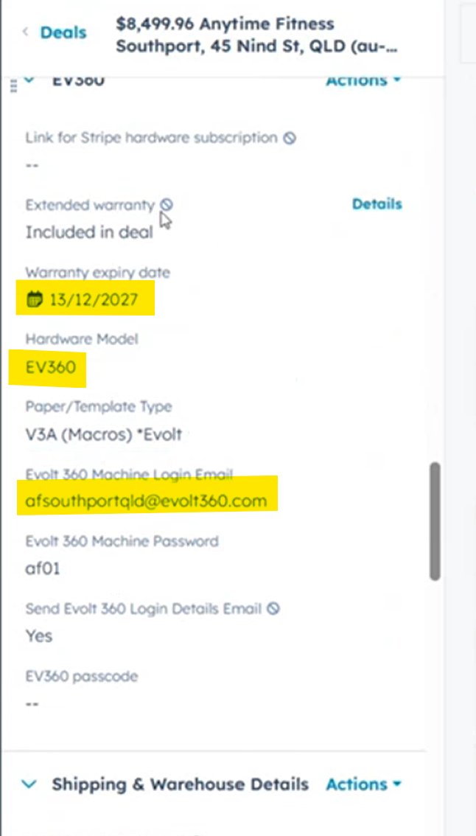

1. Select Yes, No, or N/A for Consumer ticket.
2. Costs and parts to be replaced will require Evolt to advise, select “Other - Defined in Ticket”, or, if certain, select the components
   1. Cost should be $0 – Evolt will update this.
   2. Authorised by will be (Riley??)
   3. Charge cost to –
      1. Under warranty – Evolt,
      2. Out-of-warranty Customer  
           
         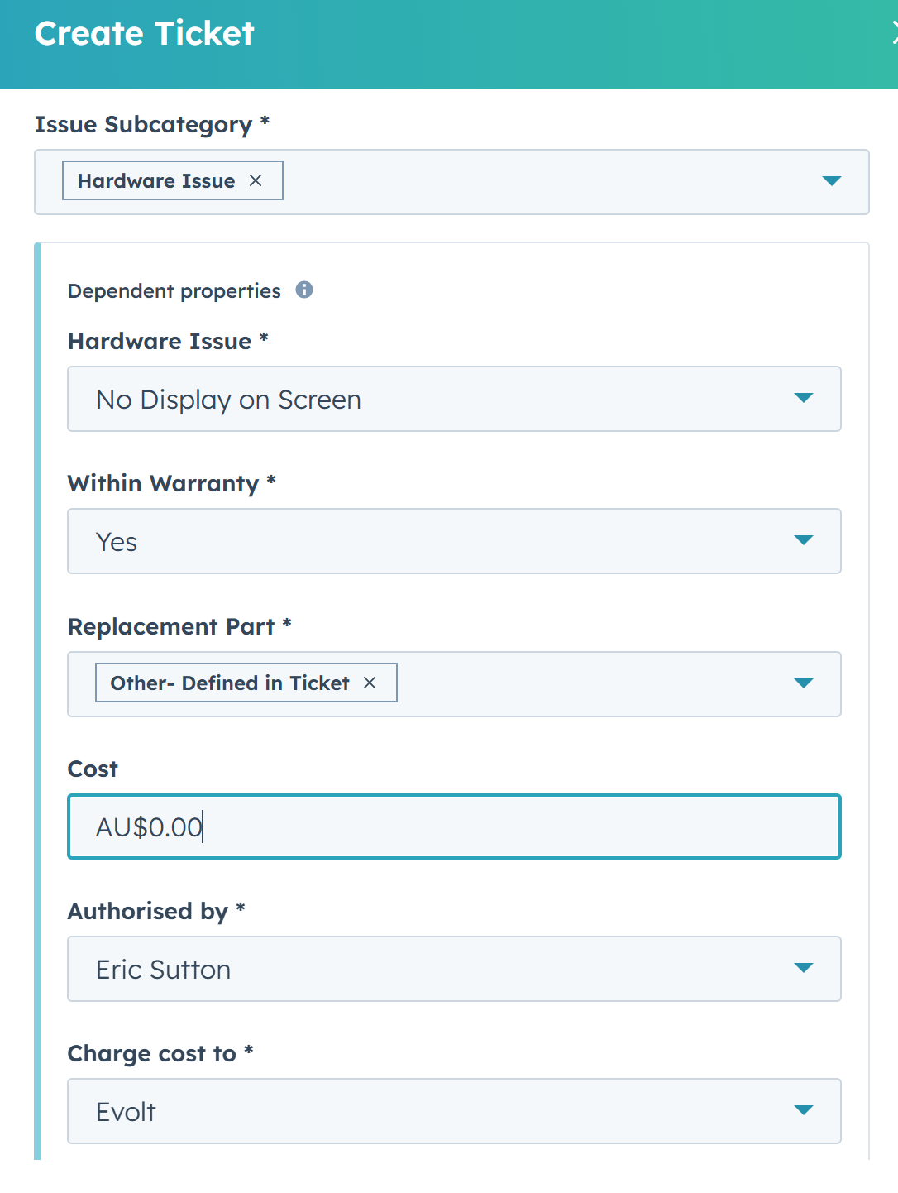
3. Select Type: Business or Consumer
4. Country the Device/Customer is located in
5. Create Date based on when the issue occurred, not the date the ticket was created
6. Issue Category – This should be prefilled based on the above selection
7. Support Category – This can be determined as part of your investigation

1. Issue Subcategory - This should be prefilled based on the above selection
2. Ticket Origin based on how the details have been received. E.g., Phone, Email, etc.
3. Ticket owner: This should initially be based on the sift Support Team AU Day(???)
4. Ticket Technician – Select from the drop-down based on the location of the customer
5. Ticket Description: Detail about the ticket and what has occurred/been communicated by the customer.
6. Priority based on the Matrix – Typically Low unless a VIP or system outage

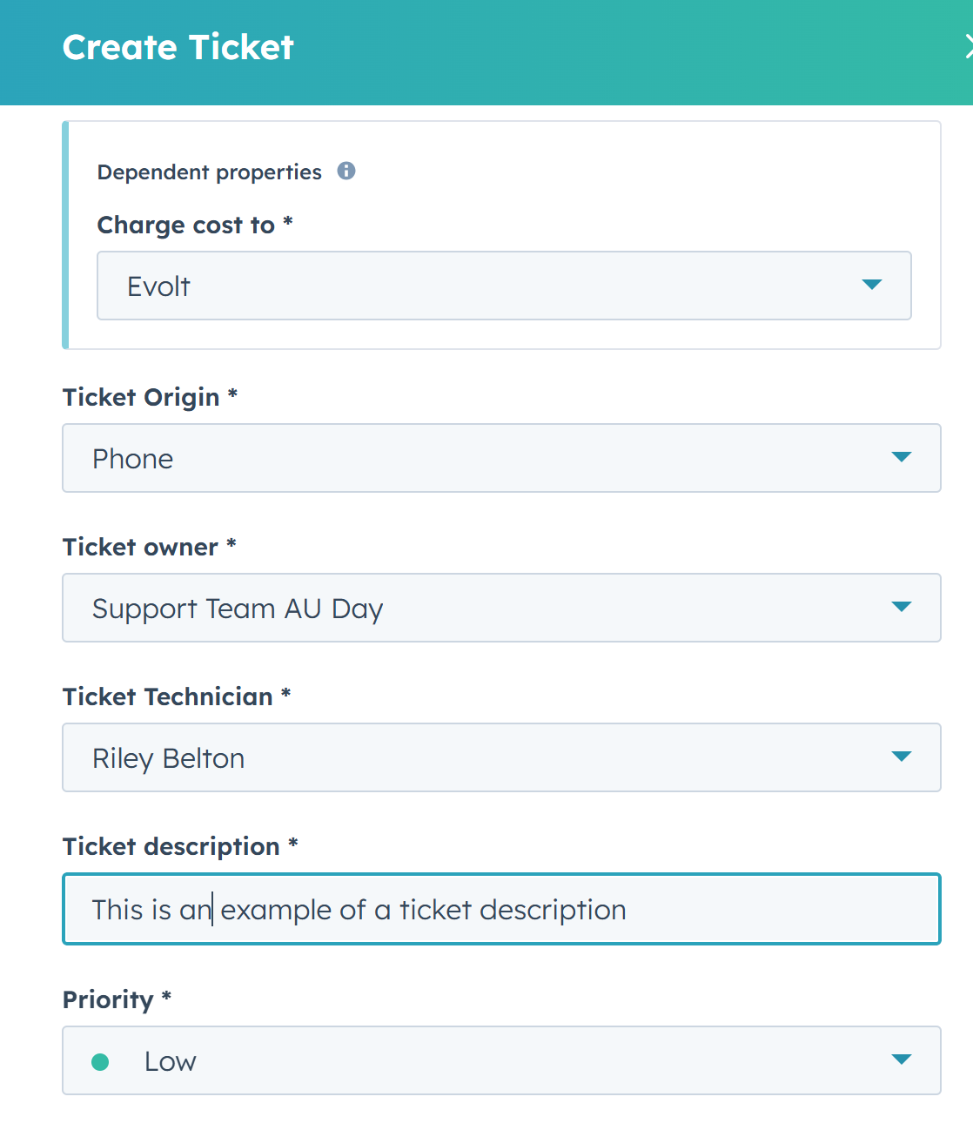

1. Associate Ticket with: Select the customer email address from the list or search for the customer
2. Companies: Select the Company the ticket is related to.
3. Select Create.

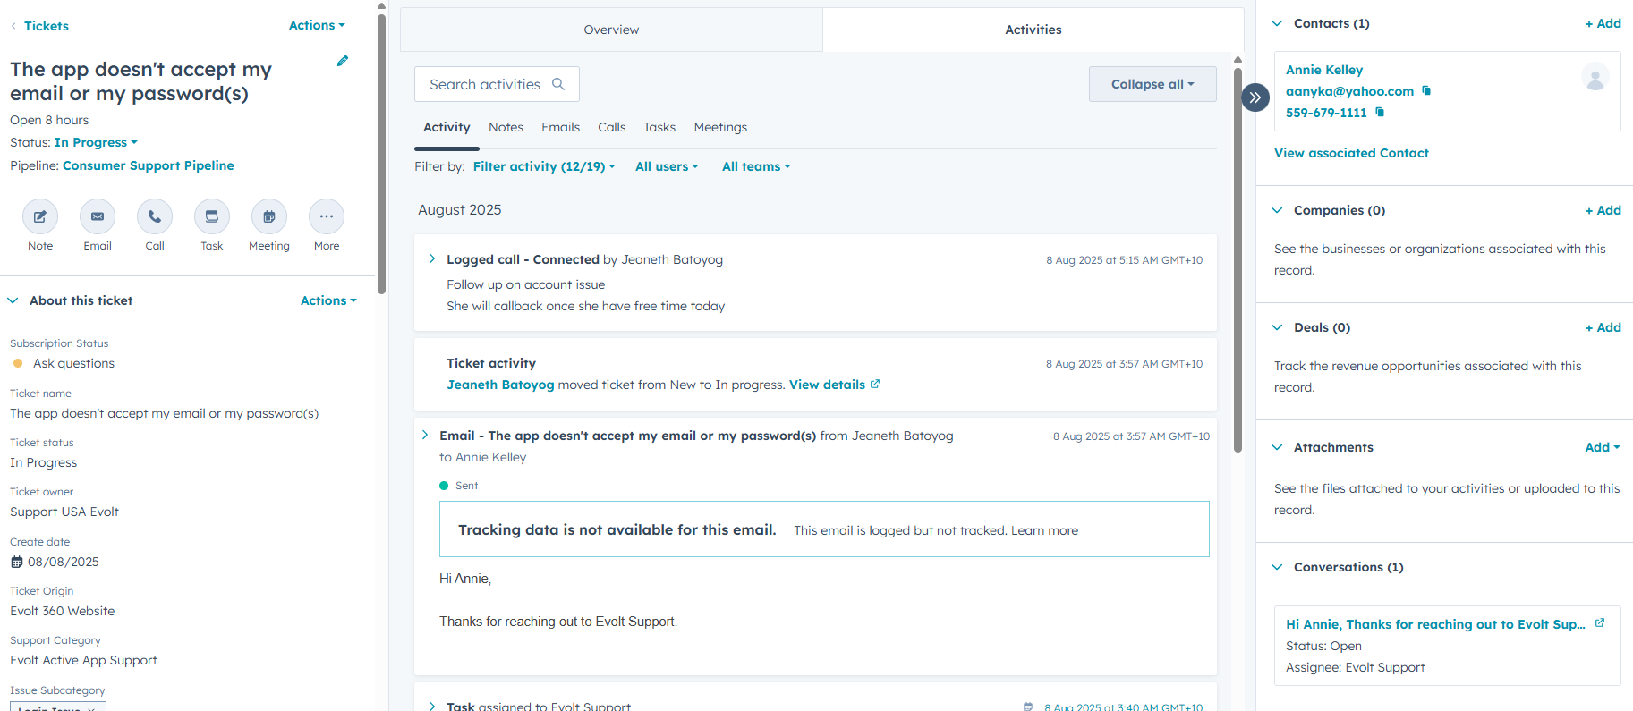

*This is what your average ticket will look like.*

### How to find ticket IDs in HubSpot

From the ticket record page:

* When you open a ticket in HubSpot, you’ll find the Ticket ID in the URL.

Example: https://app.hubspot.com/contacts/6319447/record/0-5/27592227435/

The number at the end is the Ticket ID.

* You can also view the Ticket ID in the ticket details panel
* Under the Company profile in the CRM

### Communicating with Users via HubSpot

Email templates can become helpful when speeding up SD workflow and boosting customer experience by carefully crafting standardised responses for acknowledging tickets, pending tickets, seeking approval, etc.   
  
You can access this resource by clicking on the Emails tab in the ticket menu and clicking “Create Email.”  
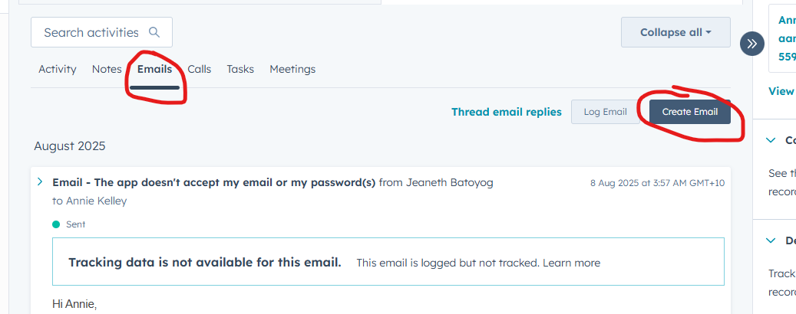

From here, you can also attach documents, schedule meetings with users, and manage ticket tasks.

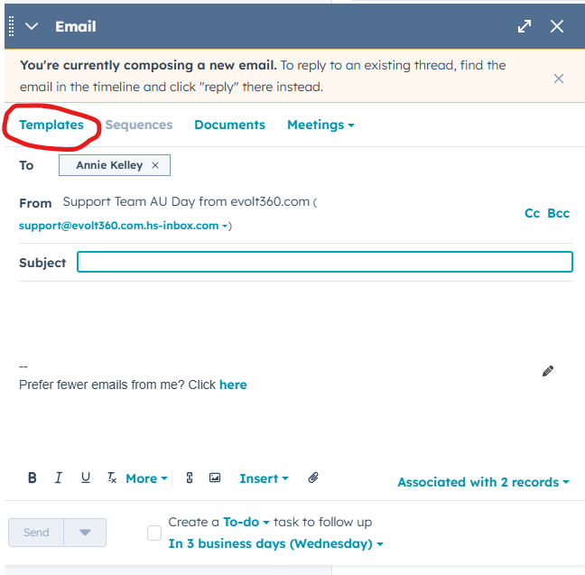

### Assigning or Reassigning Tickets

When you need to assign the ticket to another team or member of the team, you need to ensure you have updated the ticket and provided any notes for the reassignment.

1. **Standard Practice is to assign it to the AU Support Queue**, but if it is an obvious escalation, assign it to Isaac (AU) or Eric (US).
2. If you need to assign to another team member due to shift changes, please add relevant notes to the team member.
3. Search for the ticket or select it from the company profile.
4. Select the Ticket Owner:

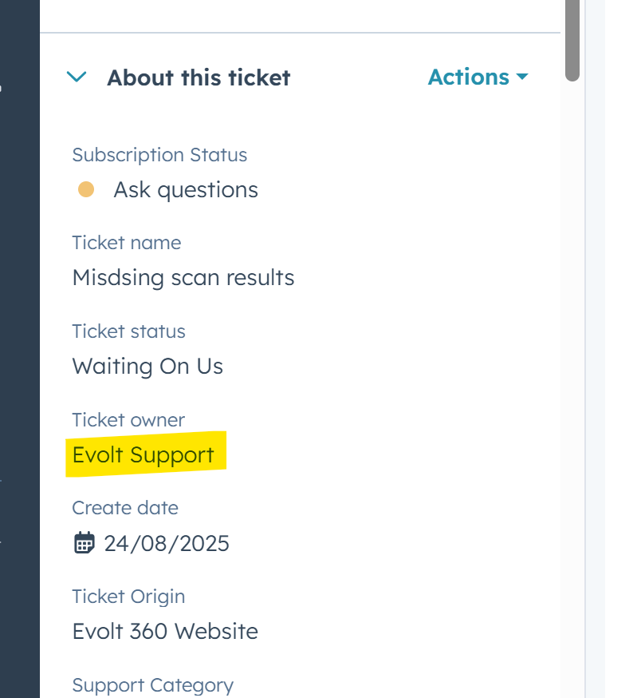

1. Select the new owner of the ticket
2. Select Activities and Notes to add a new update for the new owner.

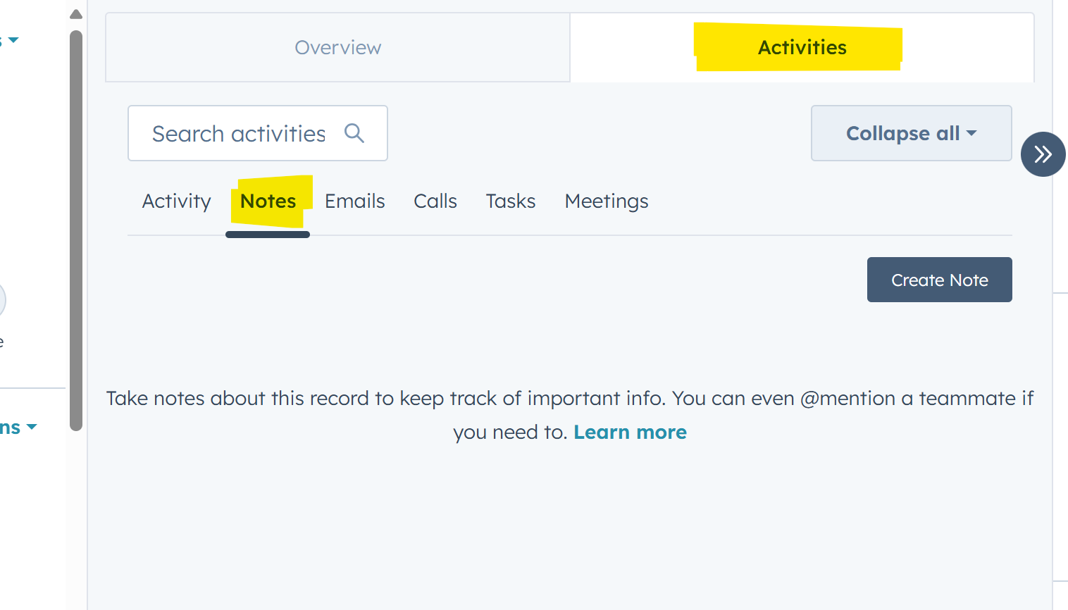

1. Notify the user (if applicable) via the communication tools in HubSpot to acknowledge the ticket update. e.g., I have escalated your ticket, and the member will be in contact with you.

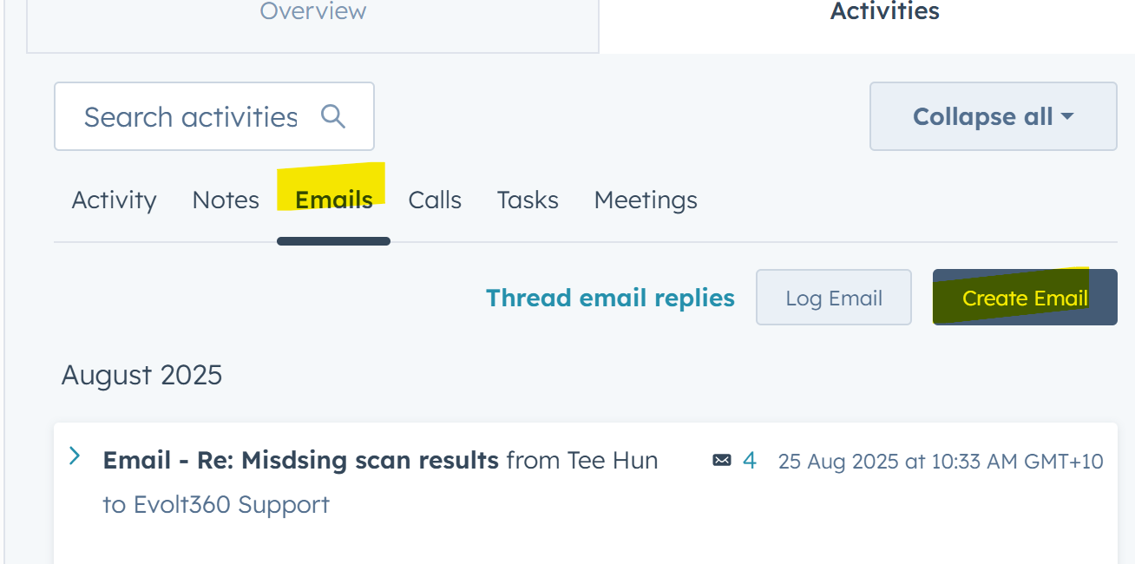

1. Provide details to the customer and any next steps and send the email.  
   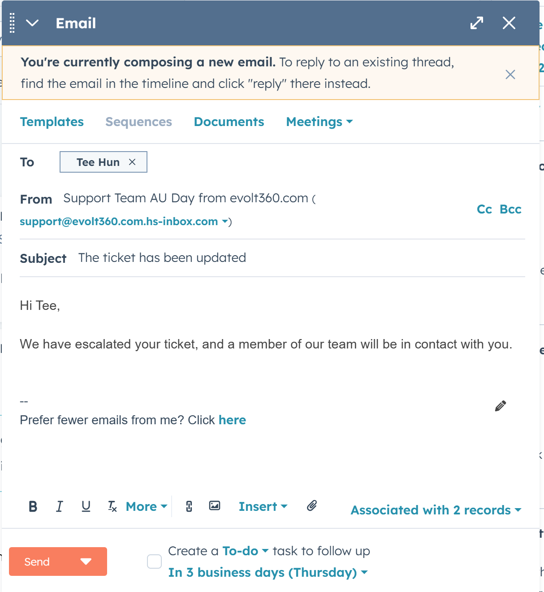

### Updating/Closing Tickets

1. Provide details of any updates to the ticket under Activities / Notes.  
   
2. Details relevant to the customer should be sent via email



1. Provide details to the customer and any next steps and send the email.  
   
2. If your investigation has been successful, or you have been advised that the ticket can be closed. Update the ticket according to the situation and email the resolution to the customer.
3. Select the status of the ticket  
   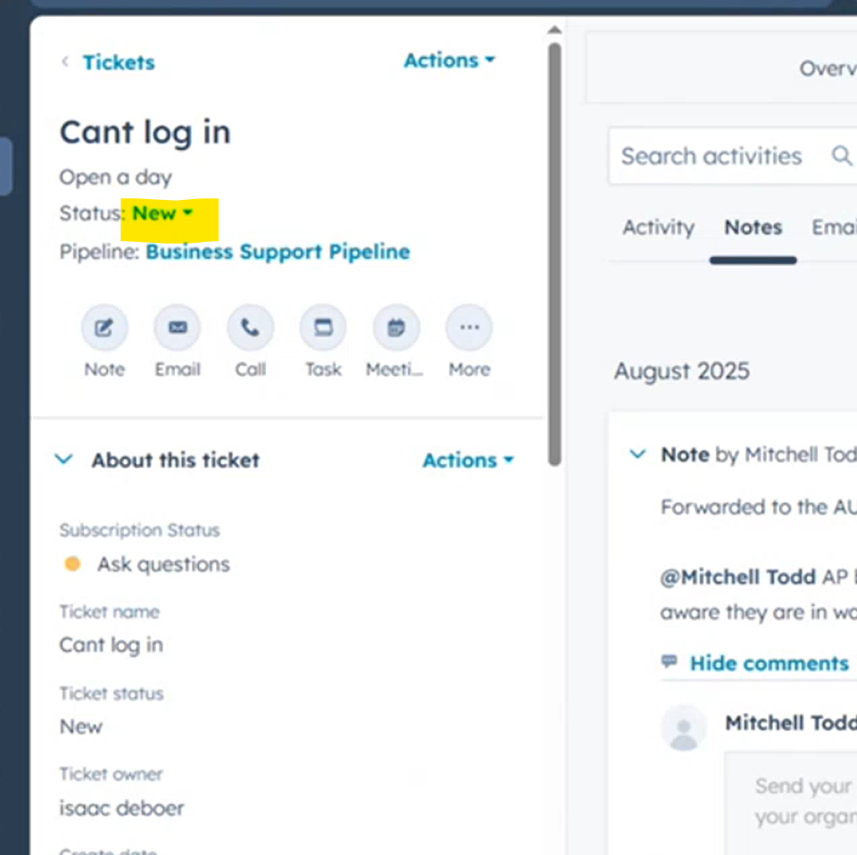
4. Select the new state – Closed, and a Solution form will be displayed
5. Enter the solution you have identified or been provided, and select Save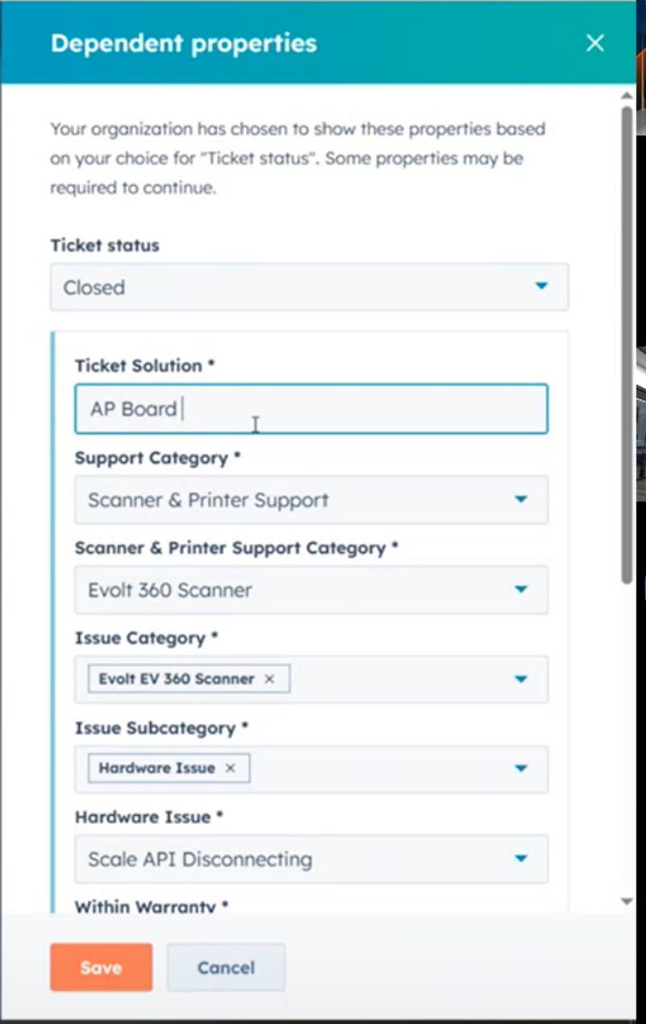

### Notes and Supporting Information

When entering ticket details, it is essential to provide complete and accurate information to ensure efficient tracking, troubleshooting, and resolution. Each ticket should include the following key elements:

* Relevant Logs: Include any system or application logs that demonstrate the issue, highlighting the critical lines where the error occurs.
* Error Messages: Record the exact error messages, including any codes or reference numbers, without paraphrasing, to allow precise identification of the problem.
* Dates and Times: Document when the issue was first observed and the timing of each troubleshooting step, using a standard format (YYYY-MM-DD) and specifying the time zone.
* Prior Contact / History: Summarise any previous actions, discussions, or related tickets to provide context and prevent duplication of work.
* Attachments, Photos, and Screenshots: Upload supporting files that illustrate the issue or provide additional context and briefly describe each attachment.

### Smart Questions to Ask the User to Help with Data Collection.

When creating a ticket, it’s important to gather complete and accurate information. Here are some helpful prompts you can ask to fill out fields efficiently:

* *Can you describe the issue in a few sentences for me?*
* *When did the issue start occurring?*
* *Have you attempted any troubleshooting steps so far through the control panel?*
* *Is this affecting just this device, or do you own multiple devices with the same issue?*
* *Can I confirm our current gym location and name?*
* *Do you need a resolution by a specific date or time?*
* *Is this related to a recent change or installation?*
* *Is this issue recurring or the first time?*

These questions can help guide the interaction and ensure that the ticket is created with the right level of detail, reducing back-and-forth and improving resolution time.

### Triage from the Inbox

#### Merge duplicate tickets

When you find duplicate tickets eg.  
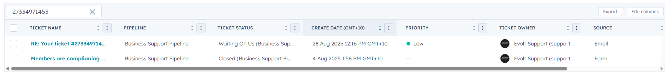

Open the parent ticket and select Merge form the Action menu at the top of the ticket  
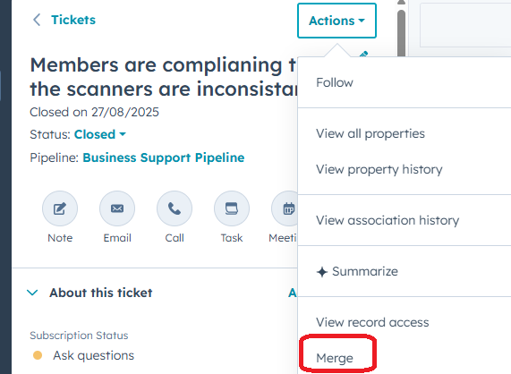

Look up the title of the ticket you are merging into this parent ticket – ensure you check that it has the correct date and time to make sure you found the correct ticket and select Merge  
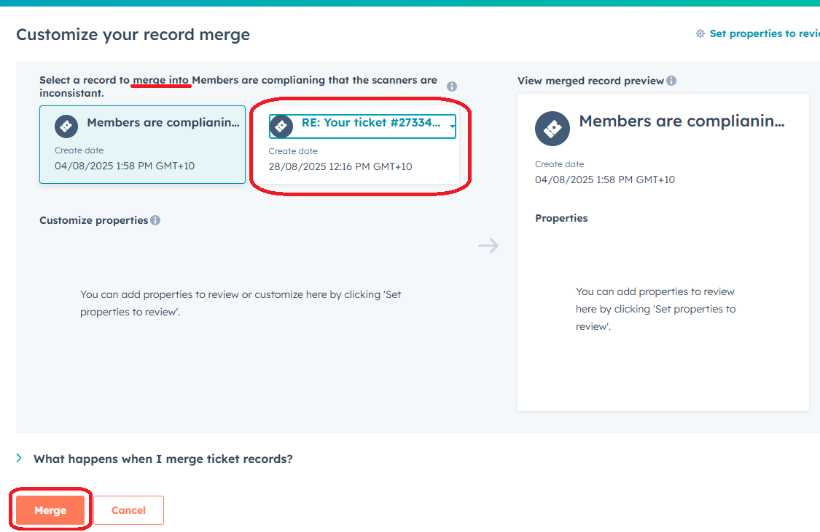

# Escalation Processes

The escalation support process for the Evolt 360 Help Desk is primarily based on ticket priority, time of day, and jurisdiction. Below are the escalation paths for different ticket types.

## Ticket Triage

In all instances, Asta is responsible for handling all tickets as the primary contact. If an issue is determined to be within scope, Asta will work closely with the client to investigate and resolve the matter, with the aim of achieving first call resolution. Where an issue cannot be resolved by Asta, falls outside of scope, or requires referral to Evolt 360 for further guidance, Asta will comprehensively document all relevant details and escalate the matter through the escalation process outlined in the table below. Follow the steps outlined below, according to the applicable priority level.

## Tickets Priority determined as P3 or P4

Any P3 and P4 tickets requiring escalation must be assigned to the appropriate Evolt 360 IT representative through the HubSpot ticketing system.

|  |  |  |
| --- | --- | --- |
| Hemisphere | Evolt 360 Escalation Point of Contact | Email Address |
| Southern Hemisphere | Isaac Deboer | [isaac.deboer@evolt360.com](mailto:isaac.deboer@evolt360.com) |
| Northern Hemisphere | Riley Belton | riley.belton@evolt360.com |

## Priority 2 Tickets

**A P2 event is an outage impacting a major Evolt 360 Customer or many Evolt 360 customers globally, of a service that prevents the end-to-end use of the Evolt 360 Platform.**

Any P2 tickets requiring escalation must be assigned to the appropriate Evolt 360 IT representative through the HubSpot ticketing system.

|  |  |  |
| --- | --- | --- |
| Time of Day (AEST) | Evolt 360 Escalation Point of Contact | Email Address |
| 7 am -7 pm | Isaac Deboer | [isaac.deboer@evolt360.com](mailto:isaac.deboer@evolt360.com) |
| 7 pm – 7 am | Riley Belton | riley.belton@evolt360.com |

## Priority 1 Tickets

**A P1 event is an outage impacting all Evolt 360 customers globally, preventing the end-to-end use of the Evolt 360 Platform. Such events include**

* 1. **Issues with all mobile applications**
  2. **Issues with all users accessing or navigating the insights platform.**
  3. **Not all kiosks are syncing scans**

If an issue is determined to be within scope, Asta will work closely with the client to investigate and resolve the matter, with the aim of achieving first call resolution. Where an issue cannot be resolved by Asta, falls outside of scope, or requires referral to Evolt 360 for further guidance, Asta will comprehensively document all relevant details and escalate the matter through the escalation process outlined below.

Any P1 tickets that require escalation are to follow the process below.

1. The service agent will make every reasonable effort to resolve the issue.
2. The service agent must ensure that all required details are accurately captured and enter them into the ticket.
3. If the issue cannot be resolved and meets the criteria for a P1 event, the agent is to assign the ticket to the respective Evolt 360 IT representative via the HubSpot ticketing system based on the time of day, as detailed below.
4. The service agent must log the incident in the team chat, including the incident details and ticket number.

|  |  |  |
| --- | --- | --- |
| Time of Day (AEST) | Evolt 360 Escalation Point of Contact | Email Address |
| 7 am -7 pm | Isaac Deboer | [isaac.deboer@evolt360.com](mailto:isaac.deboer@evolt360.com) |
| 7 pm – 7 am | Riley Belton | riley.belton@evolt360.com |

1. The service agent is to contact the Evolt 360 Chief Technology Officer. Informing them of the issues and advising whom within Evolt 360 this was escalated to.
2. If there is no response from the Evolt 360 Chief Technology Officer in 10 minutes, the Chief Information Officer is to be contacted.

|  |  |  |  |  |
| --- | --- | --- | --- | --- |
| Title | Name | | Phone | Email |
| Chief Information Officer | Chris Simpfendorfer | 0414 488 164 | | [chris.simpfendorfer@evolt360.com](mailto:chris.simpfendorfer@evolt360.com) |
| Chief Technology Officer | Danny Towstyi | +61 7 5535 6227 | | danny@evolt360.com |

1. Contact the SDM directly and inform them of the situation.
2. SDM to contact Evolt 360 to assist and resolve the issues.

## Ticket Escalation Flow



# Kiosk Troubleshooting Guide & Common Issues

## Device Not Powering On

|  |  |  |  |
| --- | --- | --- | --- |
| Issue | Symptoms | Steps to Resolve | Notes/ KB Ref |
| Device not powering on | * Device does not turn on when user presses power button * No lights or response from kiosk | 1. Confirm if device is plugged into a power board. 2. Instruct user to plug device into a separate wall socket (not on the same power board/outlet group). 3. If device powers on > issue is likely with original socket/power board.  4. Advise user to keep device on wall socket until faulty outlet is inspected. | Power boards with multiple high-draw devices (treadmills, elliptical, scanners) can overload and short out.   Escalate to site electrician if outlet related.  Escalate to L2 if unable to diagnose further.   KB Article: <https://knowledge.evolt360.com/knowledge/scanner-is-not-turning-on> |

## Faulty Handle

**Possible Causes:**

* Physical damage to handle wires
* Broken or unusable handles

**Resolution Step**

* Check if the wires show signs of physical damage
  + If yes > Not covered by warranty. Escalate to **Isaac.**
* If the handles themselves are broken (not just wires) > Escalate to **Mitchell** for organising replacement parts.

## Faulty Scale Board

**Possible Causes:**

* Inaccurate weight readings (often due to clothing, transportation, calibration drift, physical damage)

**Resolution Steps:**

* Recalibrate the scale through the **Scale Configuration Menu** in the Control Panel



* To reset (tare) the scale:
  + Place a **20kg** plate on the scale (given that the device is at a gym)
  + This will re-zero the measurement for more accurate readings.
* If the issue persists > Escalate to **Isaac** or **Danny** to arrange an onsite technician (manual adjustment with screwdriver may be required)

## White Screen (“of Death”)

|  |  |  |  |
| --- | --- | --- | --- |
| Symptom | Root Cause | Resolution | Escalation/KB Ref |
| Kiosk displays a white screen and becomes unresponsive | Firmware-related fault (more common in international locations) | Service Desk to immediately escalate. Technical team may need to run diagnostic scripts, capture snapshots, after initial troubleshooting by SD walking user through firmware updates and process. | **Current:** Isaac  **Pending Confirmation:** Formal process for Danny/Technical Team  KB Article: <https://knowledge.evolt360.com/knowledge/scanner-is-stuck-on-a-white-screen> |

**7.5 Printer Not Detected**

|  |  |  |  |
| --- | --- | --- | --- |
| Symptom | Root Cause | Resolution | Escalation |
| Printer no detected by kiosk/scanner | * **Unsupported printer model (non-Brother, e.g., Epson)** * **Internet connectivity issues** * **USB Lock enabled?** | **1. Confirm printer model (only Brother MFC/HL supported)**  **2. Verify internet connection**  **3. Check if USB Lock is enabled and disabled if needed.** | If printer is unsupported, gym’s on-site IT support must implement a workaround, if user hesitant to buy a new printer.   Escalate only if supported Brother model still fails after checks. |

## Relevant KB Articles:

* **Compatible Printers:** [**https://knowledge.evolt360.com/knowledge/compatible-printer-s**](https://knowledge.evolt360.com/knowledge/compatible-printer-s)
* **Printer Jamming:** [**https://knowledge.evolt360.com/knowledge/printer-jamming**](https://knowledge.evolt360.com/knowledge/printer-jamming)
* **Disabling Deep Sleep:** [**https://knowledge.evolt360.com/knowledge/disabling-deep-sleep-on-the-printer**](https://knowledge.evolt360.com/knowledge/disabling-deep-sleep-on-the-printer)
* **Scanner & Printer Support Request:** [**https://knowledge.evolt360.com/knowledge/2-scanner-printer-support-request**](https://knowledge.evolt360.com/knowledge/2-scanner-printer-support-request)
* **Connect Printer to Evolt 360 Scanner:** [**https://knowledge.evolt360.com/knowledge/connect-the-printer-to-the-evolt-360-body-scanner**](https://knowledge.evolt360.com/knowledge/connect-the-printer-to-the-evolt-360-body-scanner)
* **Connecting Scanner to Brother Printer via Wi-Fi:** [**https://knowledge.evolt360.com/knowledge/connecting-the-scanner-to-the-brother-printer-via-wi-fi**](https://knowledge.evolt360.com/knowledge/connecting-the-scanner-to-the-brother-printer-via-wi-fi)
* **Connect Evolt Scanner to HP M203W Printer:** [**https://knowledge.evolt360.com/knowledge/how-to-connect-evolt-360-scanner-to-hp**](https://knowledge.evolt360.com/knowledge/how-to-connect-evolt-360-scanner-to-hp)

## USB Device Recognition Errors

|  |  |  |  |  |
| --- | --- | --- | --- | --- |
| Issue | Root Cause | Troubleshooting Steps | Escalation Path | Related KB Article |
| USB Device recognition errors | **Lock USB setting enabled –** blocks USB access ad can disrupt internet connectivity, making the kiosk appear Offline in Control Panel | 1. Navigate to the system menu  2. Check Lock USB setting. 3. If set to On, change it to Off. 4. In the Control Panel, click the refresh button to save and apply changes.  5. Verify device recognition and connectivity. | Confirm if there is any physical damage to the Wi-Fi dongle.  If issue persists after confirming Lock USB setting, escalate to Technical Team for deeper troubleshooting | N/A |

## Network Connectivity (Wi-Fi vs LAN)

|  |  |  |  |  |
| --- | --- | --- | --- | --- |
| Issue | Symptoms | Root Cause | Troubleshooting | Escalation |
| **Network Connectivity Issue (Wi-Fi / LAN)** | User logged out unexpectedly  Control Panel shows Offline  Red “Start Scanning” button not visible | Faulty Wi-Fi dongle  Internet service interruptions  Temporary power outages or electrical shorts | 1. Verify if user is logged out and Control Panel shows offline.  2. Inspect Wi-Fi dongle for faults.  3. Confirm red “Start Scanning” button is visible.  4. Check for recent internet outages or power interruptions at the facility.  5. Reconnect device to network (LAN or Wi-Fi) as appropriate | Escalate to Technical Team if connectivity cannot be restored after basic checks. |

## Wi-Fi Dongle Faults

|  |  |  |  |  |
| --- | --- | --- | --- | --- |
| Issue | Symptoms | Root Cause | Troubleshooting | Escalation |
| Wi-Fi dongle faults | Device cannot connect to network.  Intermittent or no connectivity | Faulty Wi-Fi dongle (supplied with kiosk, not manufactured by Evolt) | 1. Advise user to temporarily connect via personal hotspot. – if this works its probably their network.  2.<https://knowledge.evolt360.com/knowledge/no-option-to-add-new-connection>  3. Document the issue in the ticket. | Escalate to Mitchell to arrange replacement dongle (covered under warranty) |

|  |  |  |  |  |
| --- | --- | --- | --- | --- |
| Issue | Symptoms | Root Cause | Troubleshooting | Escalation |
| User Profiles and Network Congestion | Increased latency  Intermittent connectivity Connection instability | Wi-Fi dongle storing excessive network profiles (often > 70) due to users connecting via personal hotspots at multiple gym locations. | 1. Access Network Panel on the Kiosk. 2. Review stored network profiles. 3. Delete unnecessary profiles, leaving only the primary network profile for stability.  4. Advise users on best practices to maintain a single network profile.   *(refer to included screenshot of Network Panel)* | N/A - Falls under standard SD scope.   Please see this KB article for more: <https://knowledge.evolt360.com/knowledge/evolt-360-scanner-housekeeping> |

## Troubleshooting Boot Failures

|  |  |  |  |  |
| --- | --- | --- | --- | --- |
| Issue | Symptoms | Root Cause | Troubleshooting | Escalation |
| Boot failures | Device fails to start  No response from kiosk | Varies, could be BIOS failure, White screen of death, outdated firmware, hardware issues. | 1. Connect a wired keyboard to the device.  2. Power cycle: turn off, then back on.  3. During startup, press Esc repeatedly to access BIOS menu.  4. If BIOS screen appears, capture a photo and forward it for escalation.   Refer to Section 14.2 for connecting to TeamViewer  Refer to Section 7.9 for firmware updates | Escalate to Isaac (AU support queue) with BIOS photo for further diagnosis. |

## TeamViewer Issues and Resolution

|  |  |  |  |  |  |
| --- | --- | --- | --- | --- | --- |
| Issue | Symptoms | Root Cause | Troubleshooting | Escalation | Related KB Articles / Notes |
| TeamViewer Issues | Remote access fails  TeamViewer password resets  Connection intermittent | Universal TeamViewer password fails 10-20% of the time.  Occasionally requires reinstallation | 1. Connect a wired keyboard to the kiosk (Mac keyboards incompatible). 2. For LP3 kiosk model: press Windows key to open the terminal. For LP/SOM models: press Ctrl + Alt + T.  3. Use touchscreen keyboard to search and open TeamViewer Host.  4. Click gear icon > Advanced Settings > Personal Password.  5. Set password to EvoltG2o18 > Apply > OK. | If a wired keyboard is purchased under warranty, keep receipt for reimbursement through Isaac or Mitchell.  For firmware updates, refer to Section 7.9 for a detailed walkthrough.  If connectivity persists after password reset, escalate to Isaac or Mitchell for further support. | Pre-configured password: EvoltG2o18 ; refer to client KB for TeamViewer host setup; |